**Maryam Hosseinali - 610398209**

Bioinformatics project2 report

**Part a- Quality control and trimming**

I conducted my project on a server available at [172.18.57.208](http://172.18.57.208/), where the SRA toolkit and FastQC were already installed, so there was no need to install them again. From the options provided, I chose SRR6191645, a colon cancer tissue sample as my cancer sample, and SRR6191646, a non-tumor tissue sample as my non-cancer sample.

fastq files were available here:

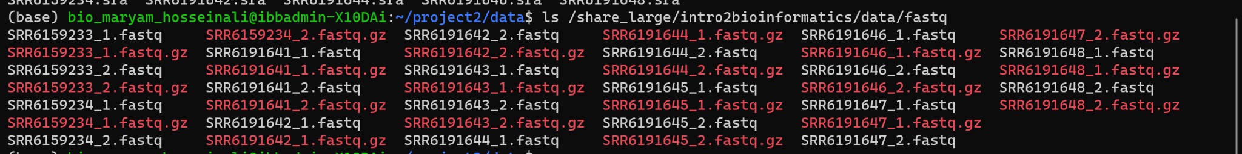

**Part A**

1)I installed fastqc using bioconda and I used Fastqc to check the quality of my sequencing data and got HTML reports for my samples:

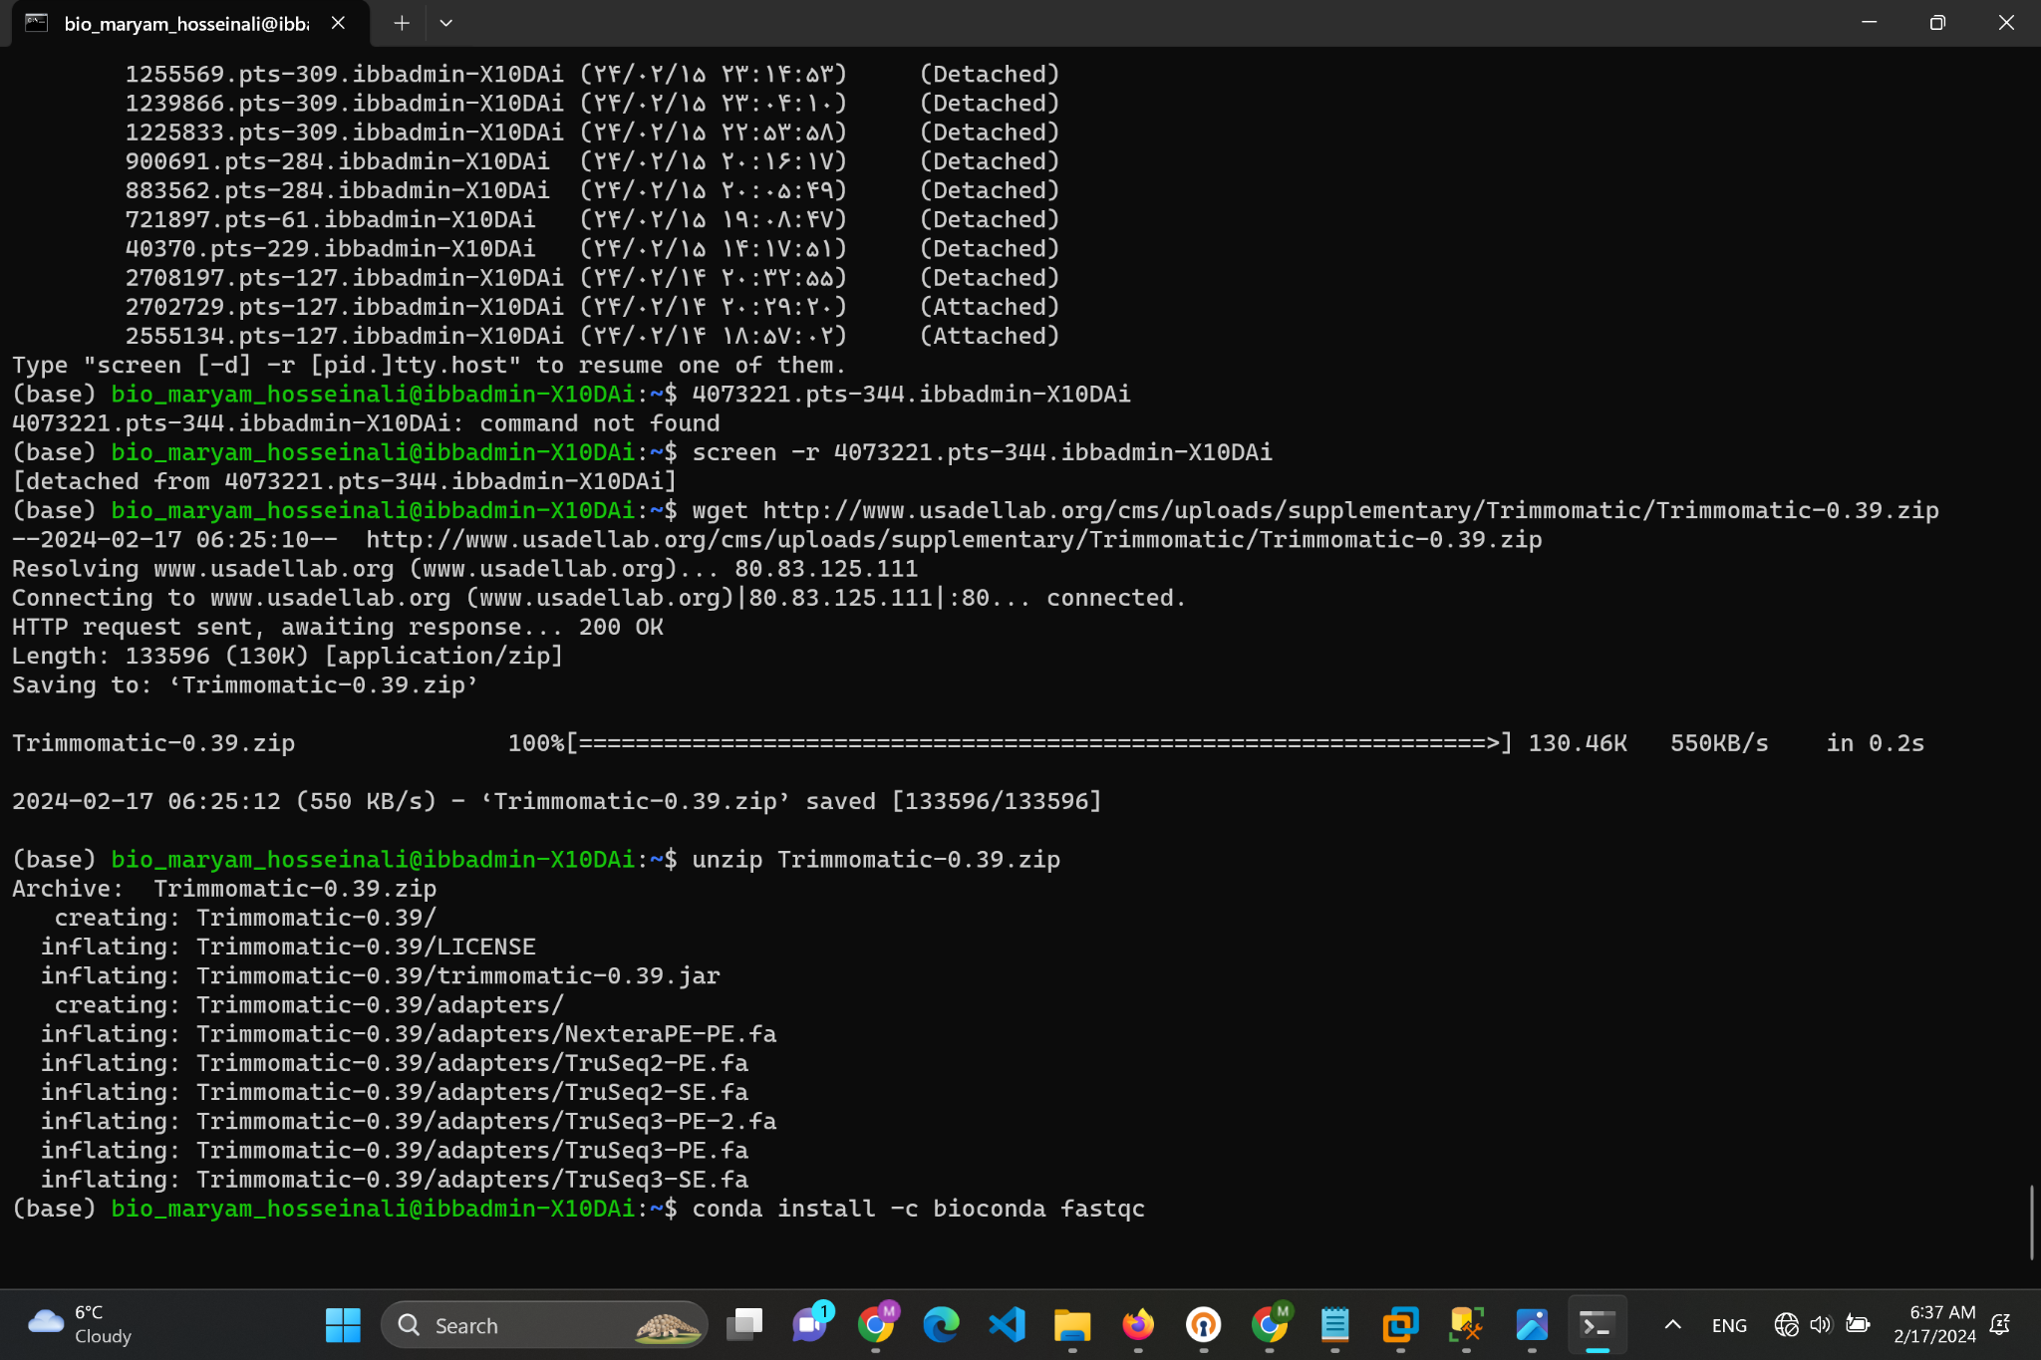

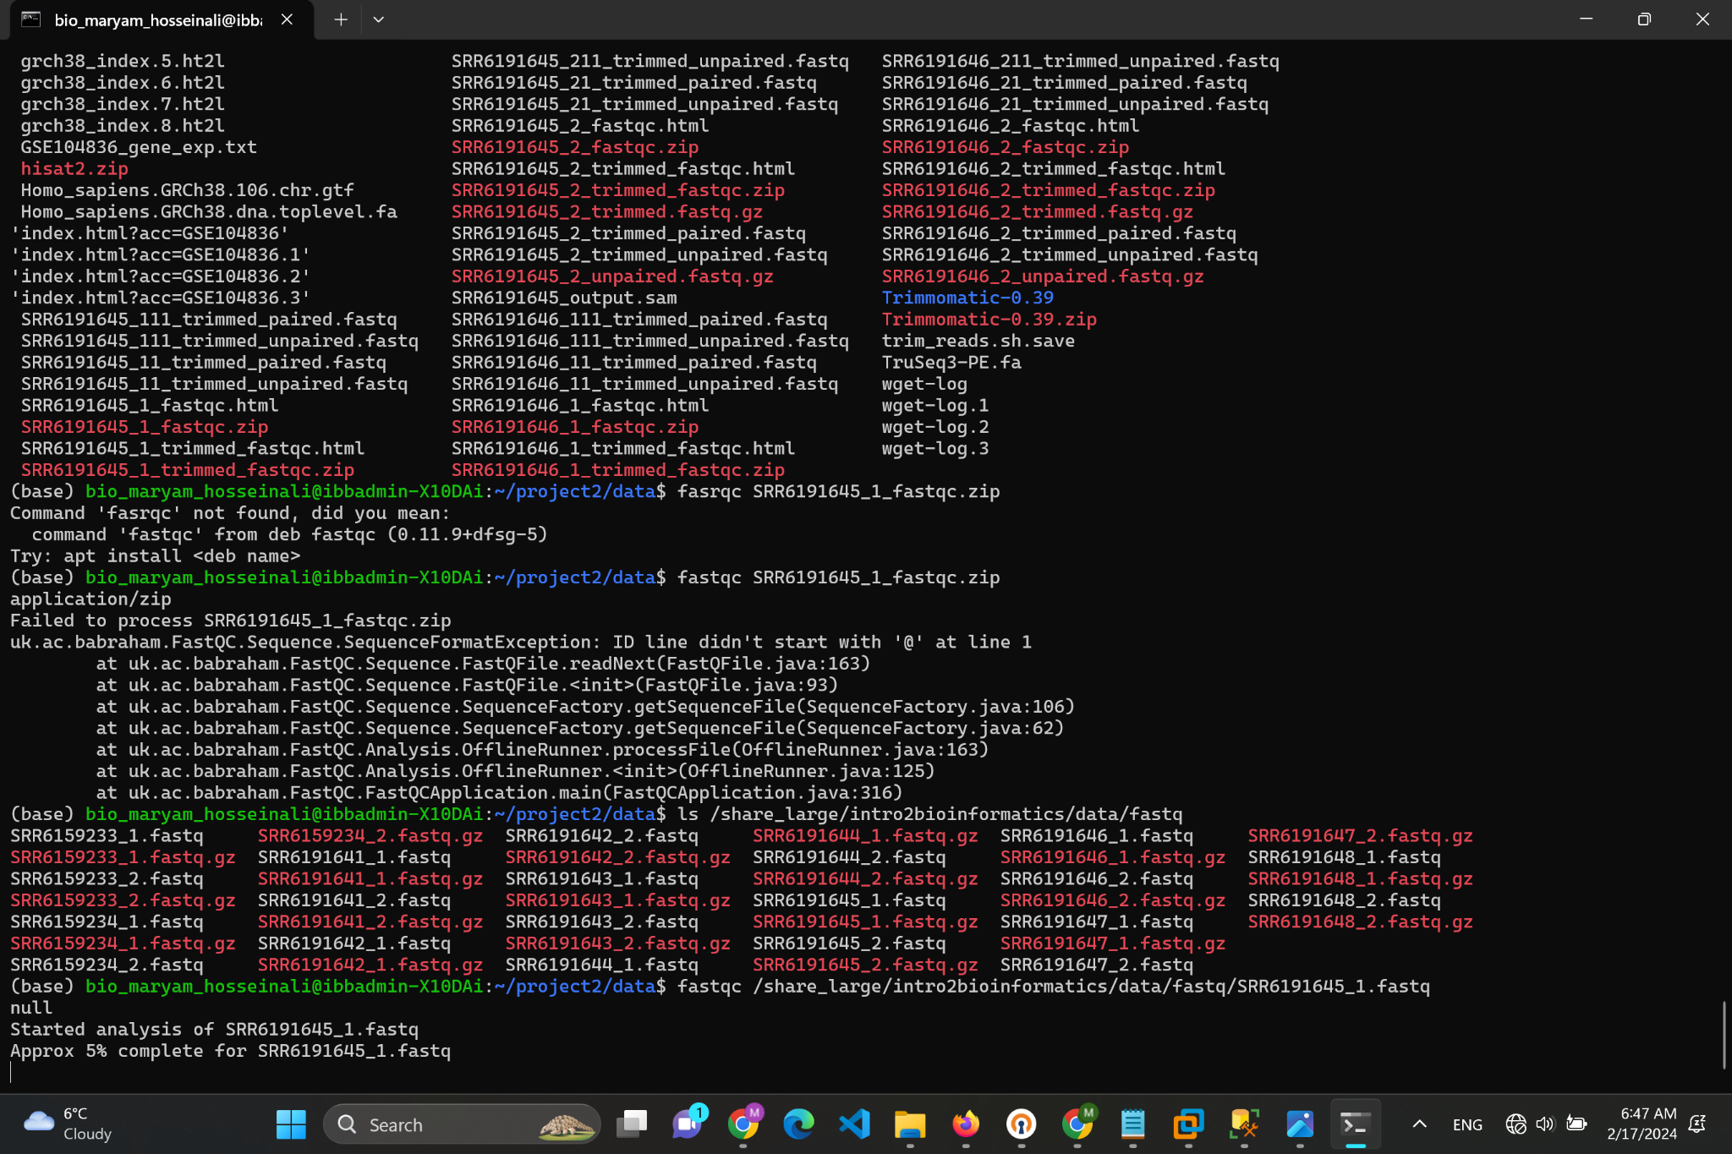

two output sample:

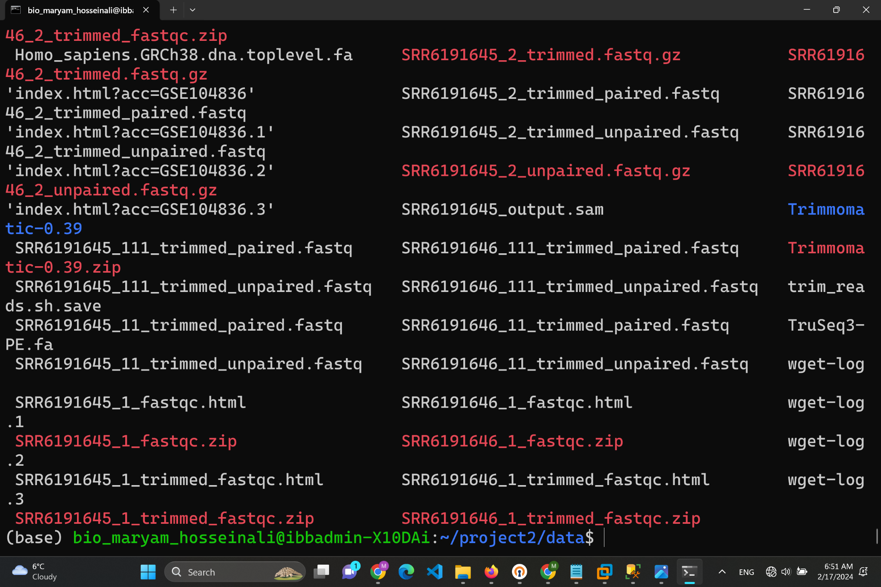

To easily view these reports, I opened them in my web browser with the command `cat report.html`. This let me see the quality of my data through charts and graphs.

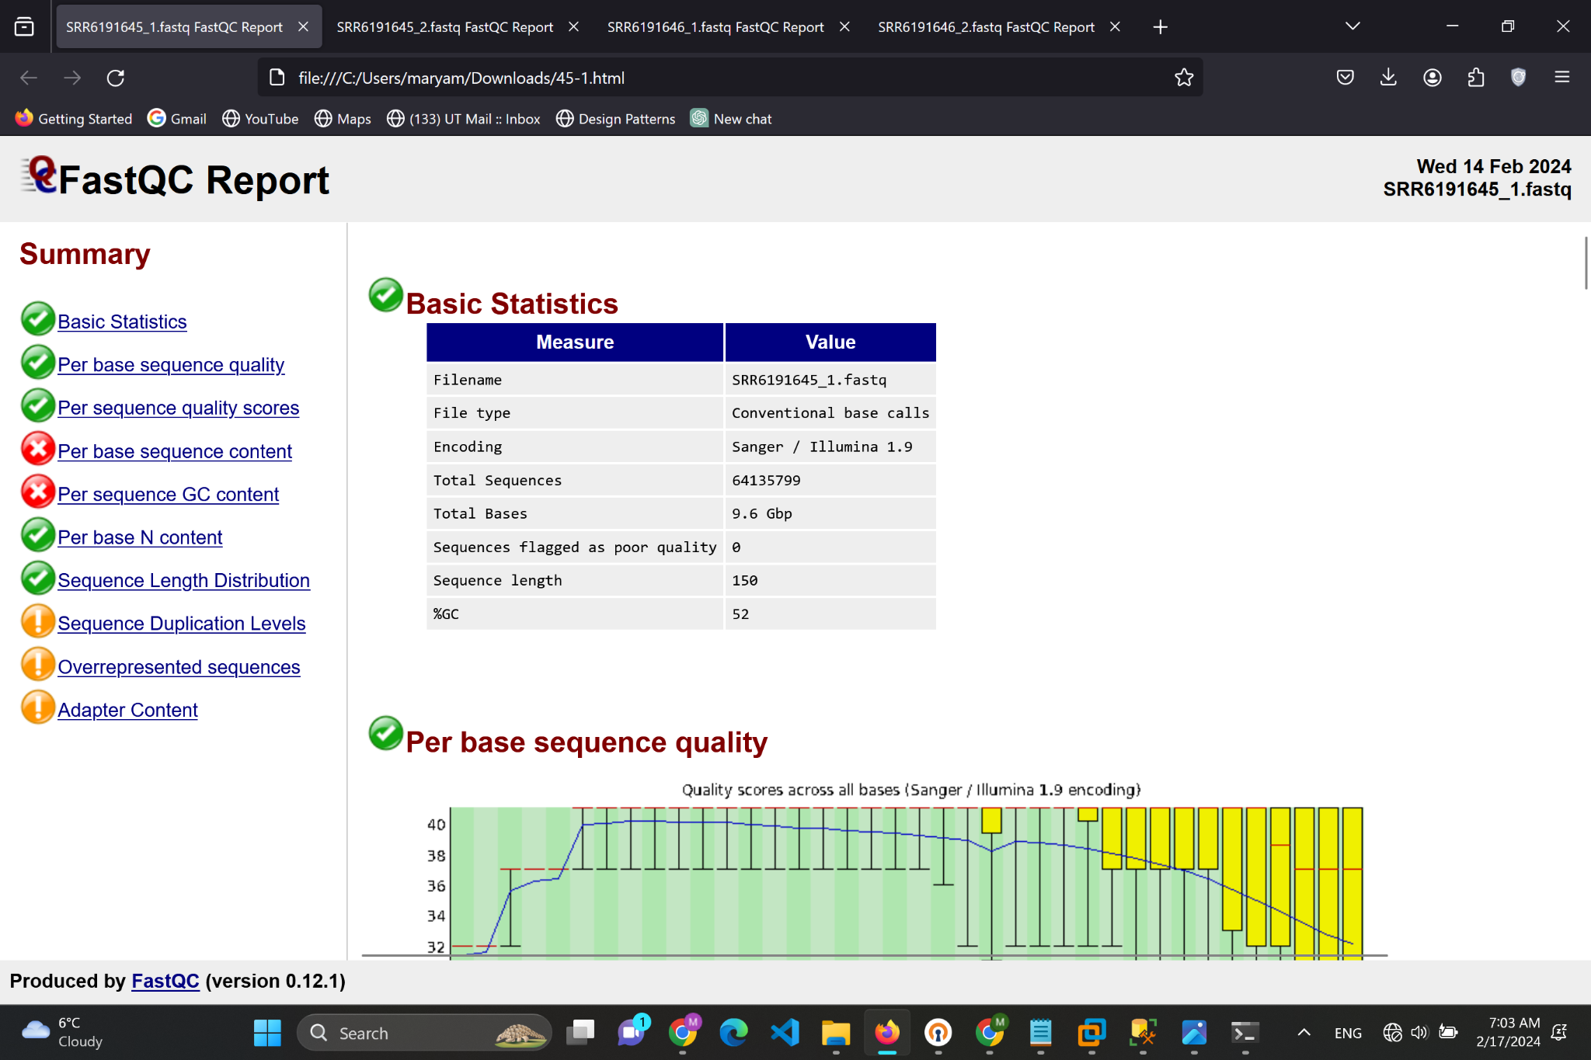

I found some issues in the "Per Base Sequence Content" and "Per Sequence GC Content" sections, shown in red, which usually means there's a problem. The issues with base sequence content might come from how the library was made or the sequencing itself, causing uneven distribution of bases. The problems with GC content could point to contamination or that the DNA I'm studying has a lot of variation in its GC content.

To fix these quality issues, I set up TrimmomaticPE, which is made for improving the quality of paired-end sequencing data. With TrimmomaticPE, I could cut out adapter sequences, get rid of low-quality ends, and remove any reads that weren't up to par. This step was crucial for making sure my data was clean and ready for deeper analysis:

First i installed and unzipped it: 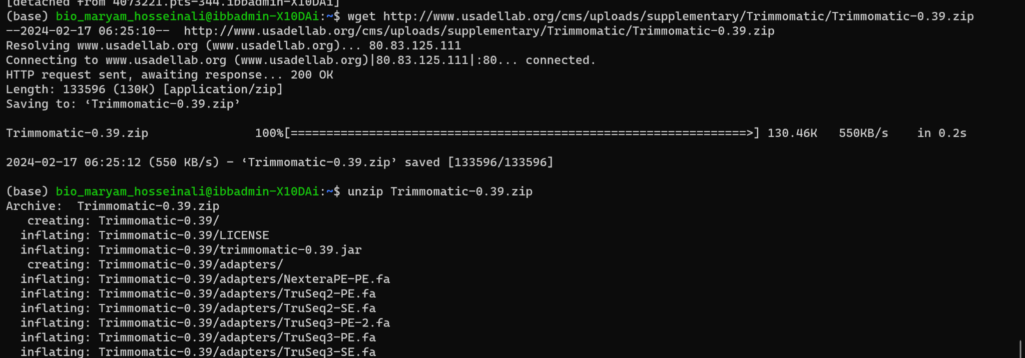

Then i started trimming: 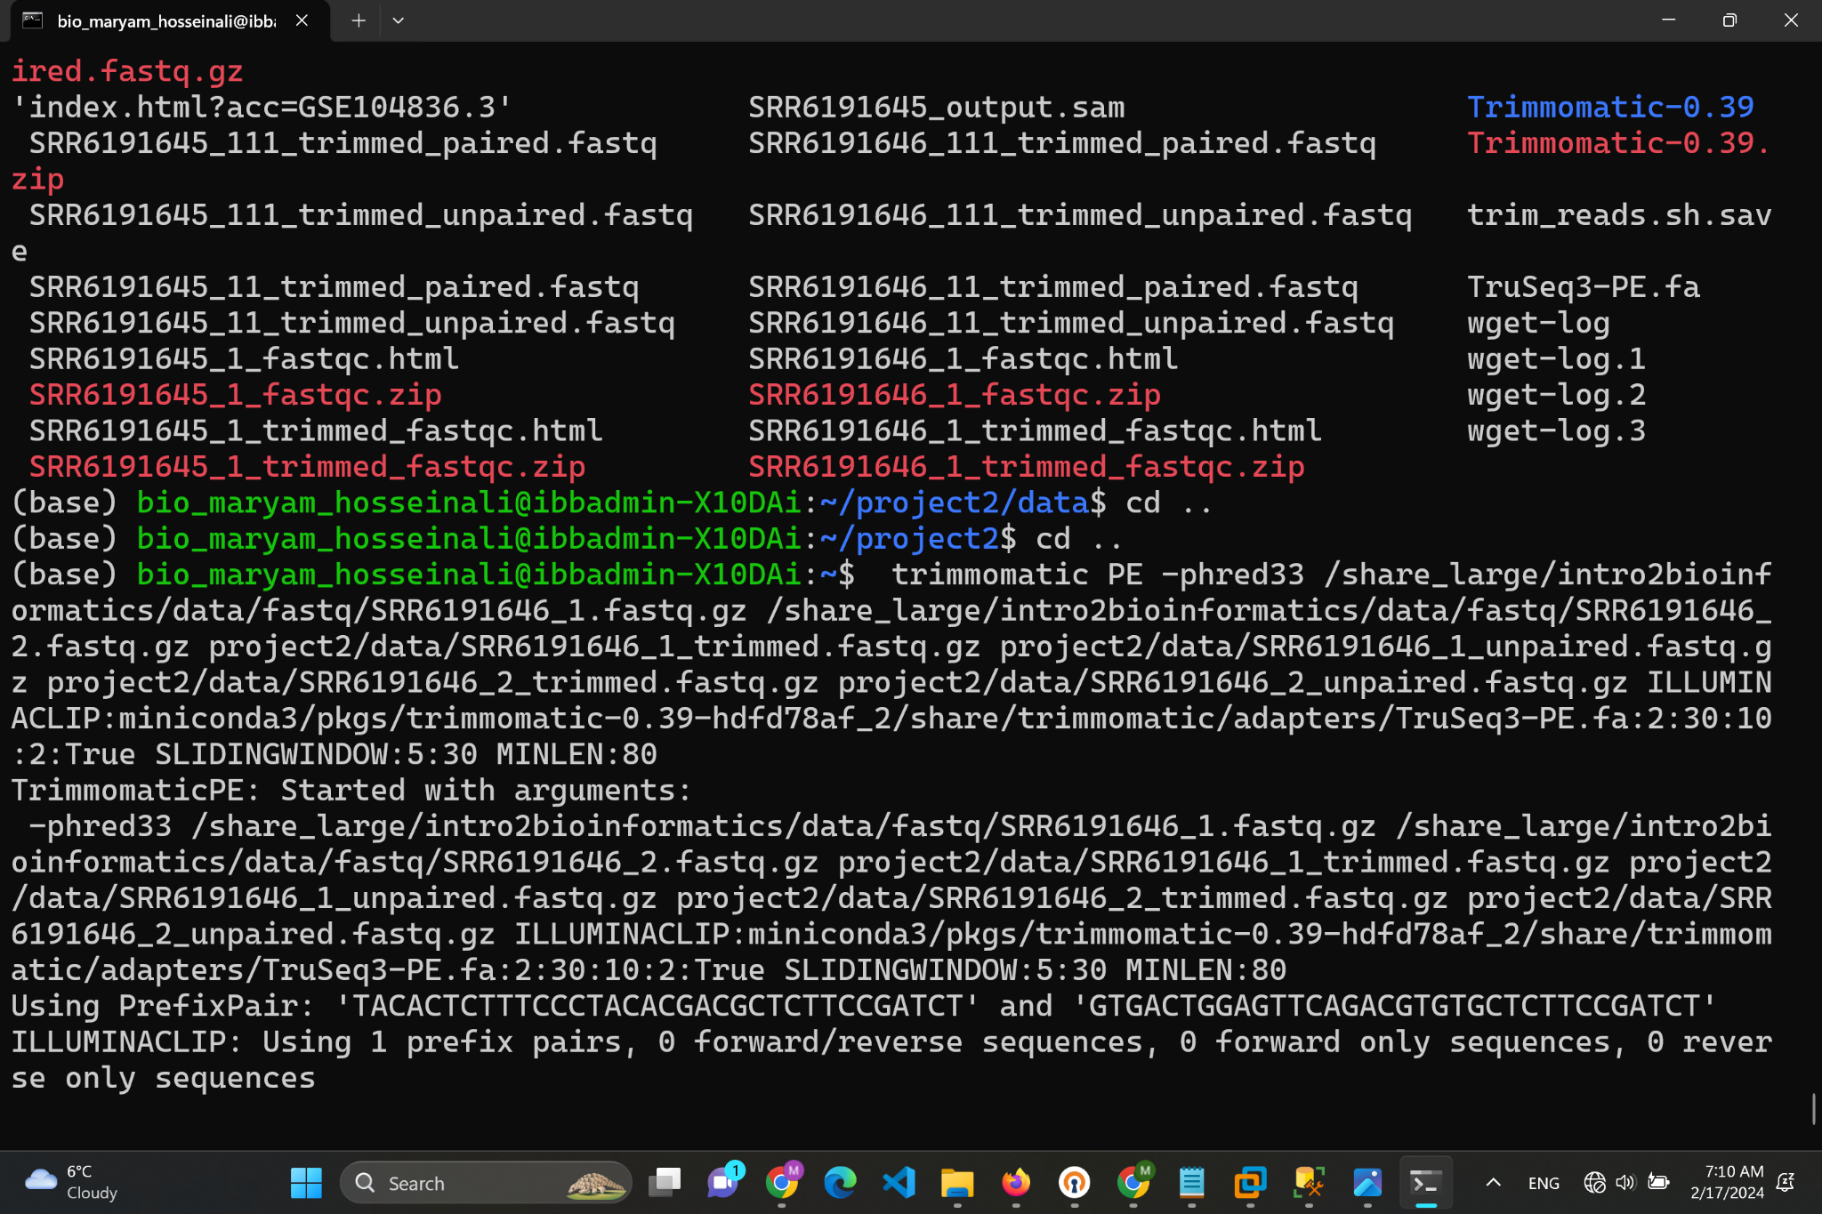

And I also used Fastqc to check the quality of my trimmed files:

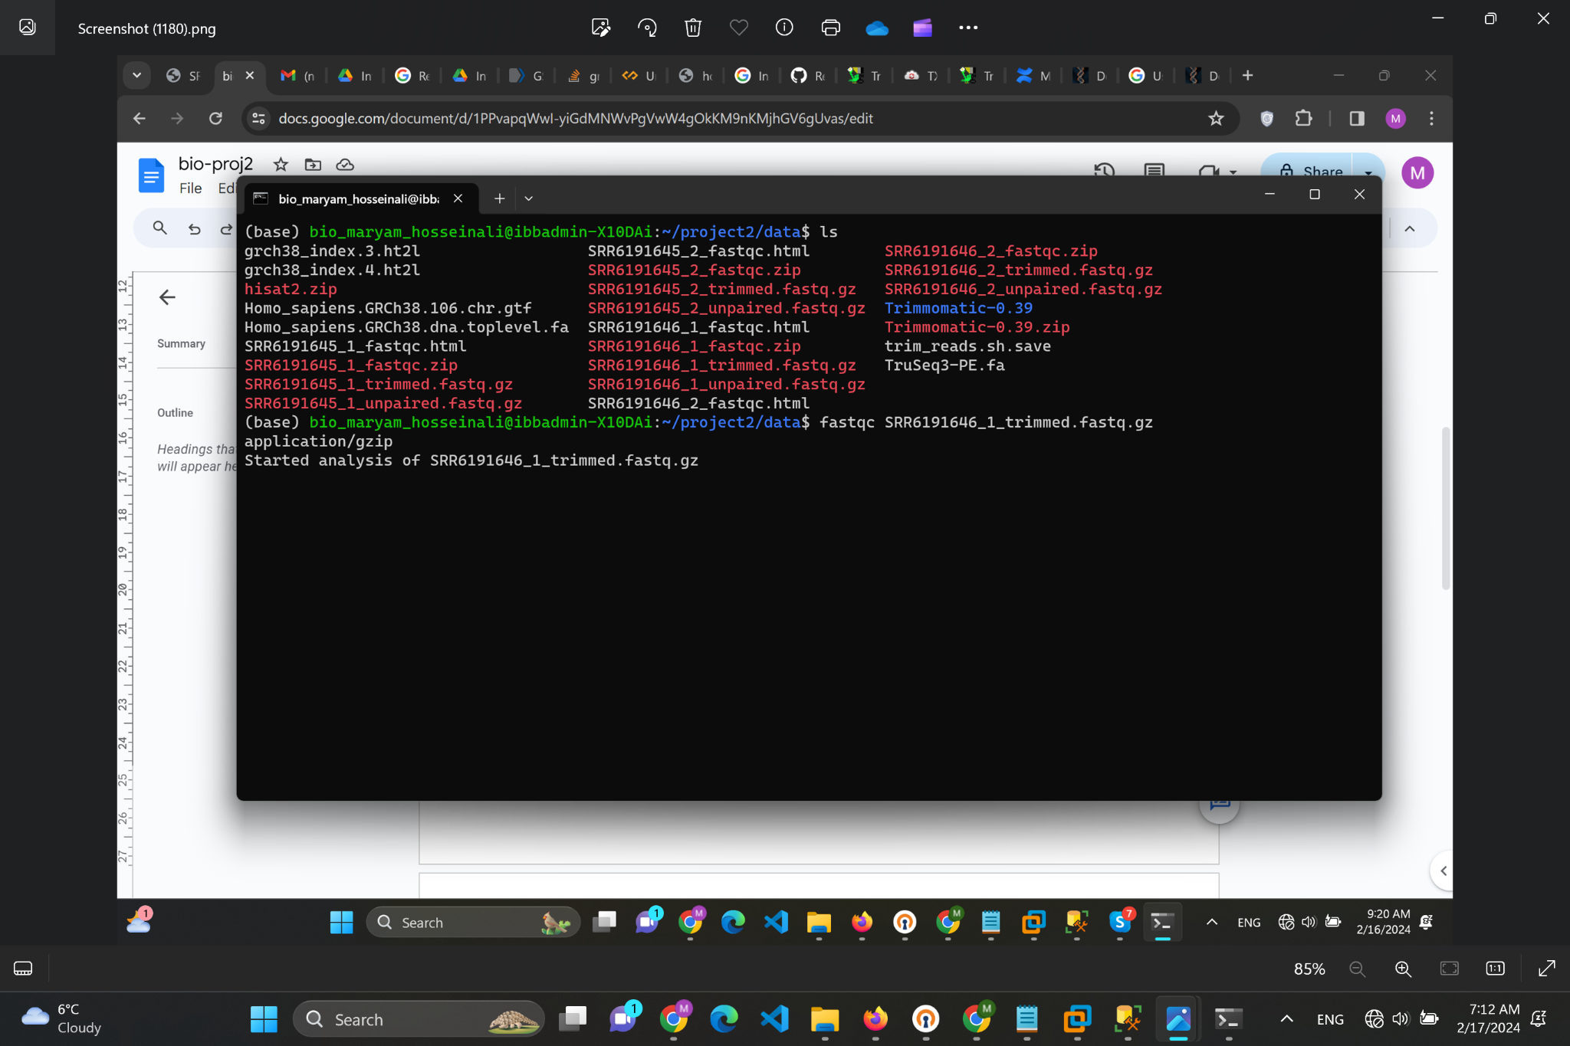

Logic behind trimming commands:

1. Quality Trimming:LEADING:30` and `TRAILING:30`: These options ensure that low-quality bases at the start and end of each read are removed if their quality score is below 30. This directly addresses the tip's requirement to "eliminate bases with a quality of less than 30.

2. Sliding Window Trimming:SLIDINGWINDOW:5:30`: This option scans the read with a 5-base wide sliding window, cutting when the average quality per base drops below 30. This further ensures that the internal parts of the reads meet the quality threshold.

3. Minimum Length:MINLEN:80`: This option discards reads that are shorter than 80 bp after trimming, which fulfills the tip's requirement to "eliminate reads shorter than 80 bp."

4. Adapter Trimming:

ILLUMINACLIP:miniconda3/pkgs/trimmomatic-0.39-hdfd78af_2/share/trimmomatic/adapters/TruSeq3-PE.fa:2:30:10:2:True`: This option removes adapter sequences from the reads. While the trimming tip does not explicitly mention adapter trimming, it is a standard practice in preprocessing sequencing data to remove any residual adapter sequences that can interfere with downstream analyses.

Trimmed files quality control also had red parts:

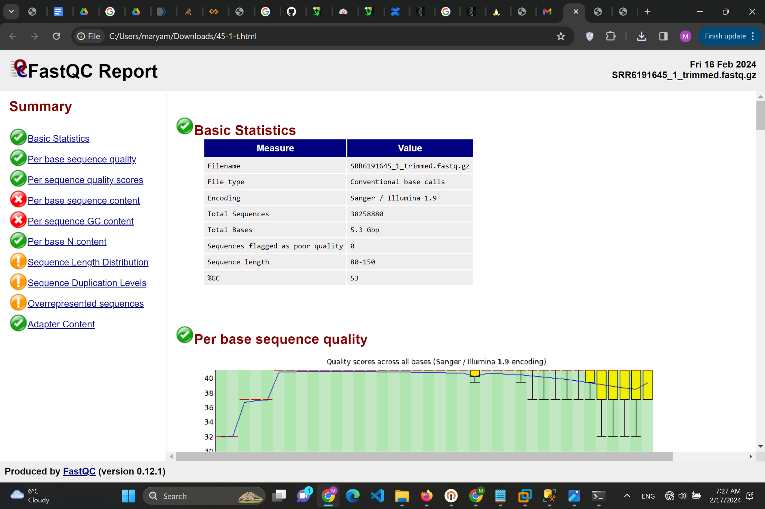

Reasons it might happen:

- Biological Variation: Natural variations in GC content across different genomic regions can lead to uneven coverage. Some organisms or genomic regions inherently have high or low GC content, which might not be normalized by trimming.

- Sequencing Biases: Certain sequencing technologies or library preparation methods can introduce biases. For example, PCR amplification during library preparation might preferentially amplify certain sequences over others.

- Incomplete Adapter Removal: While trimming can remove most adapter sequences, some reads might have partial adapter sequences that are not fully removed, especially if the adapter sequences vary slightly from the expected.

- Quality Score Calibration: The interpretation of quality scores can vary between sequencing platforms. Some platforms might produce reads with naturally lower scores at certain positions, which trimming might not correct.

These factors can lead to persistent warnings in FastQC reports even after trimming.

1)What is the average number of reads across samples before and after the read trimming?

First let provide basic statistic of all of them:

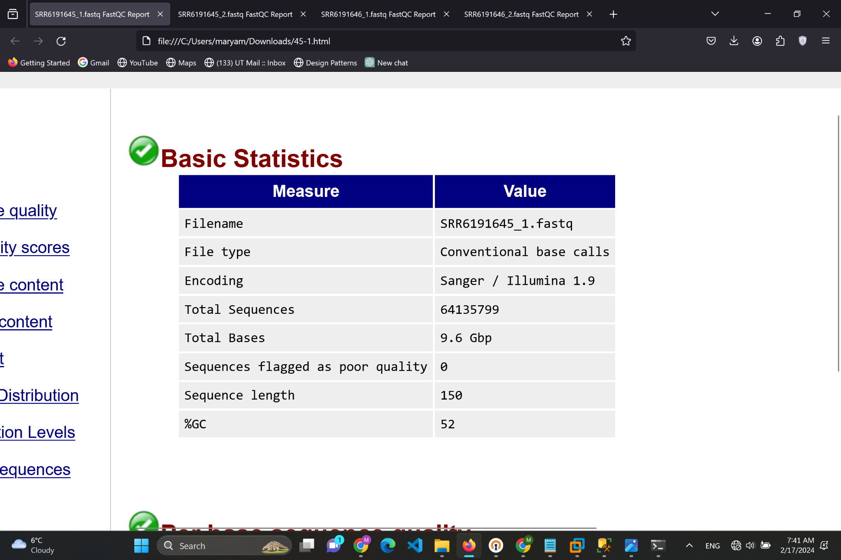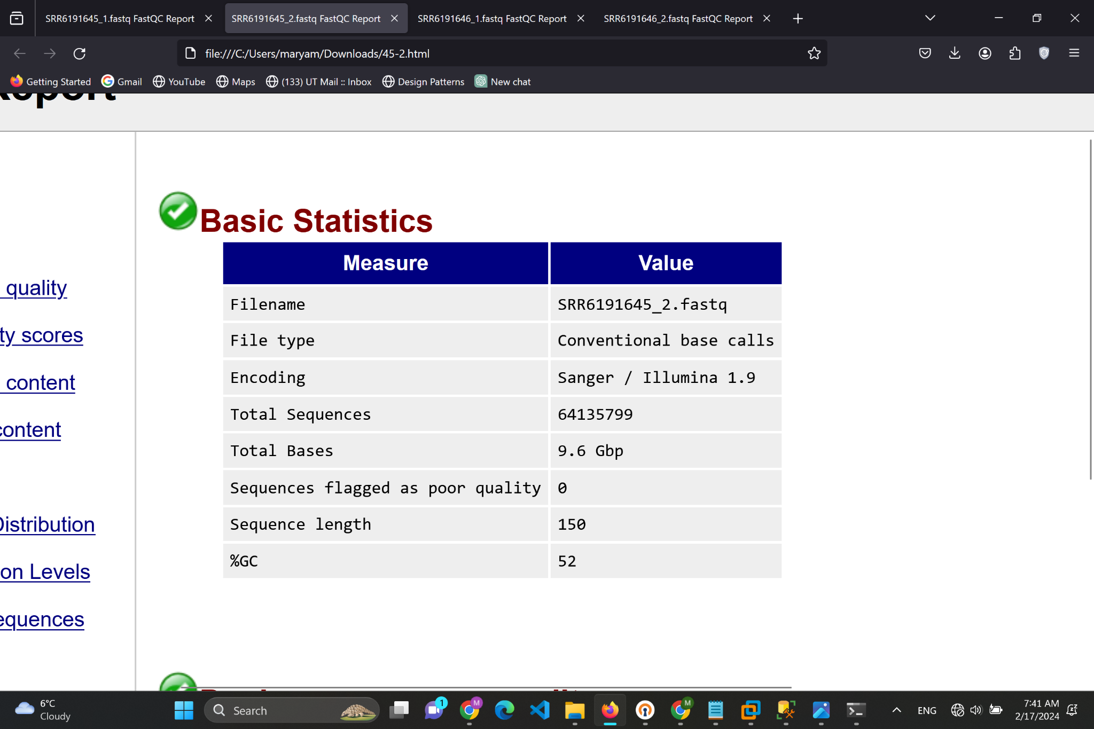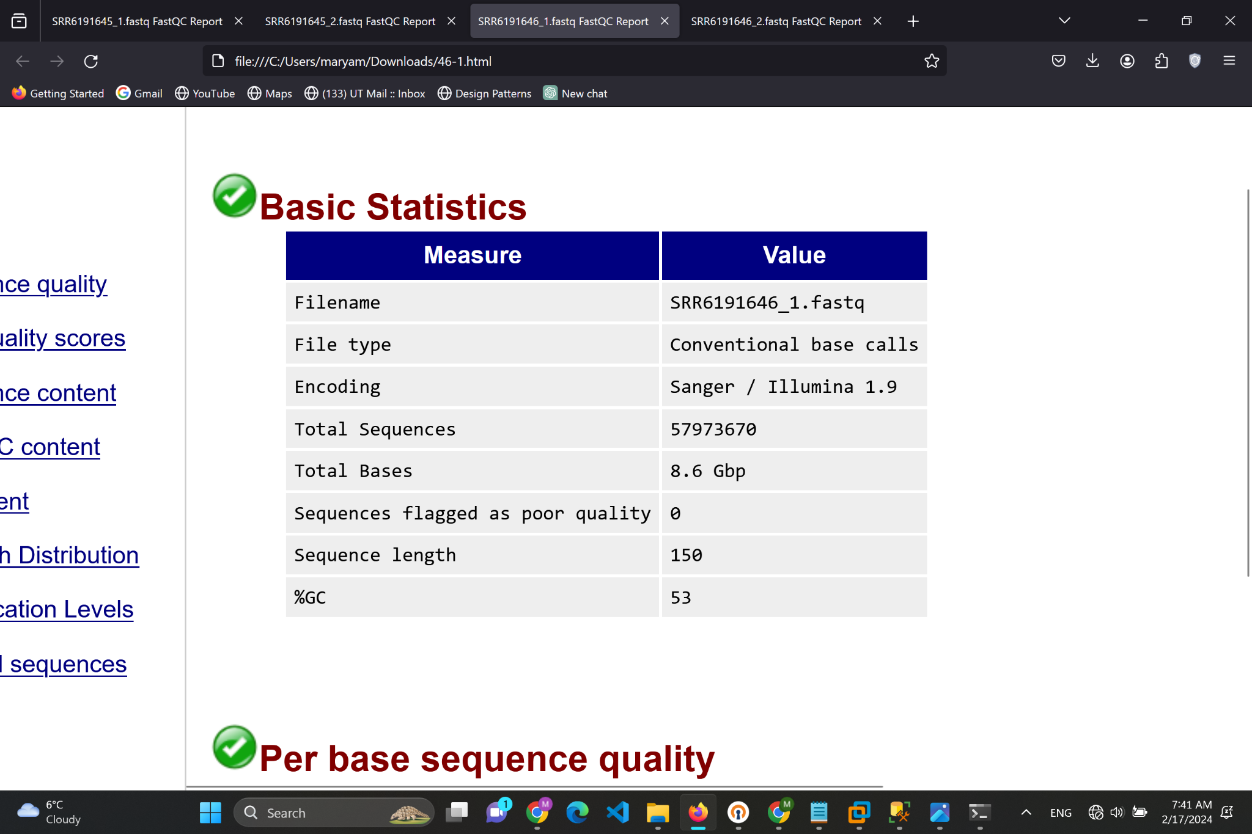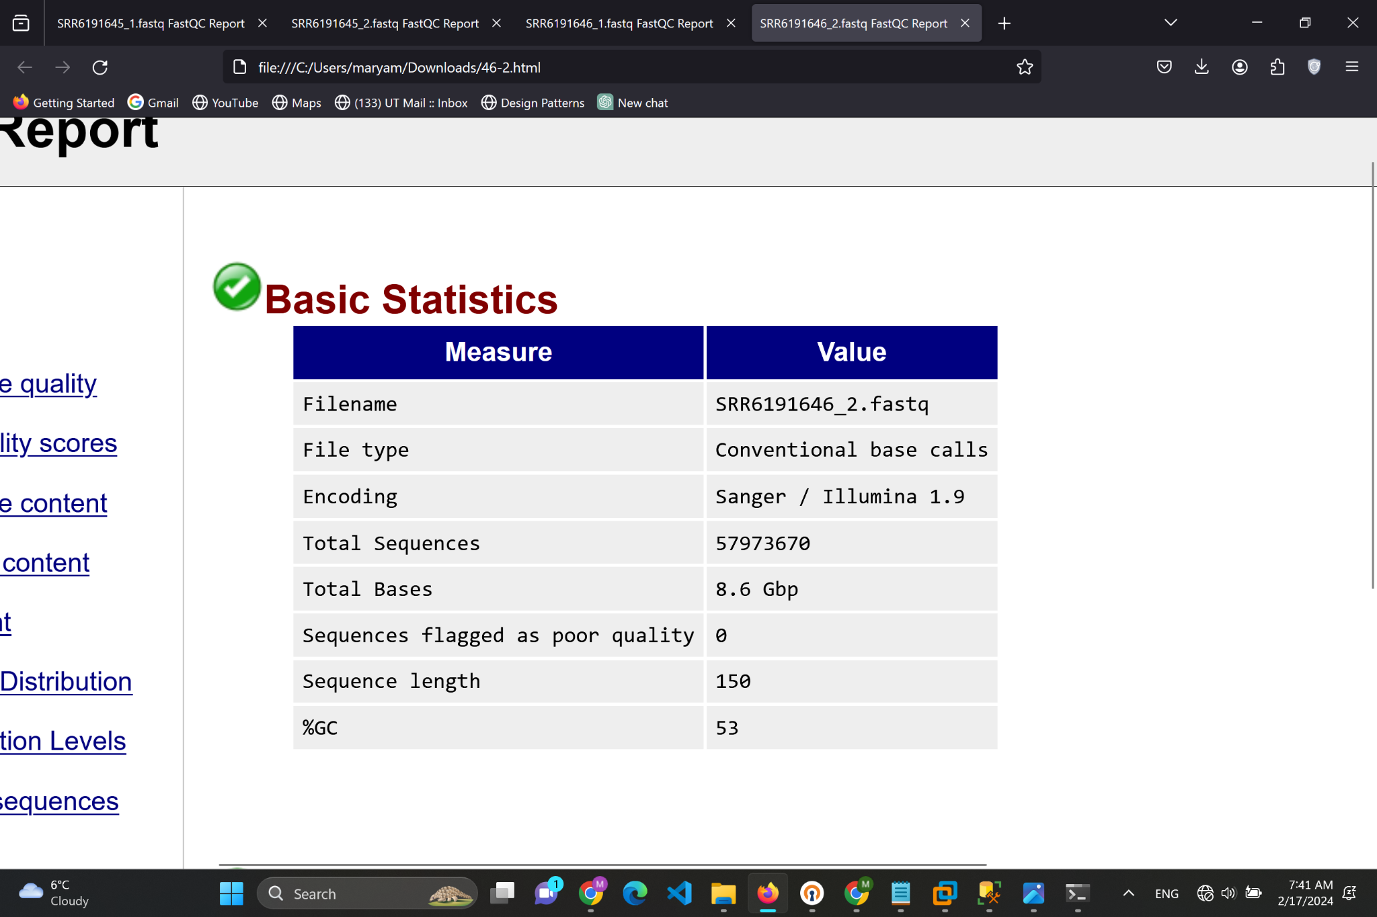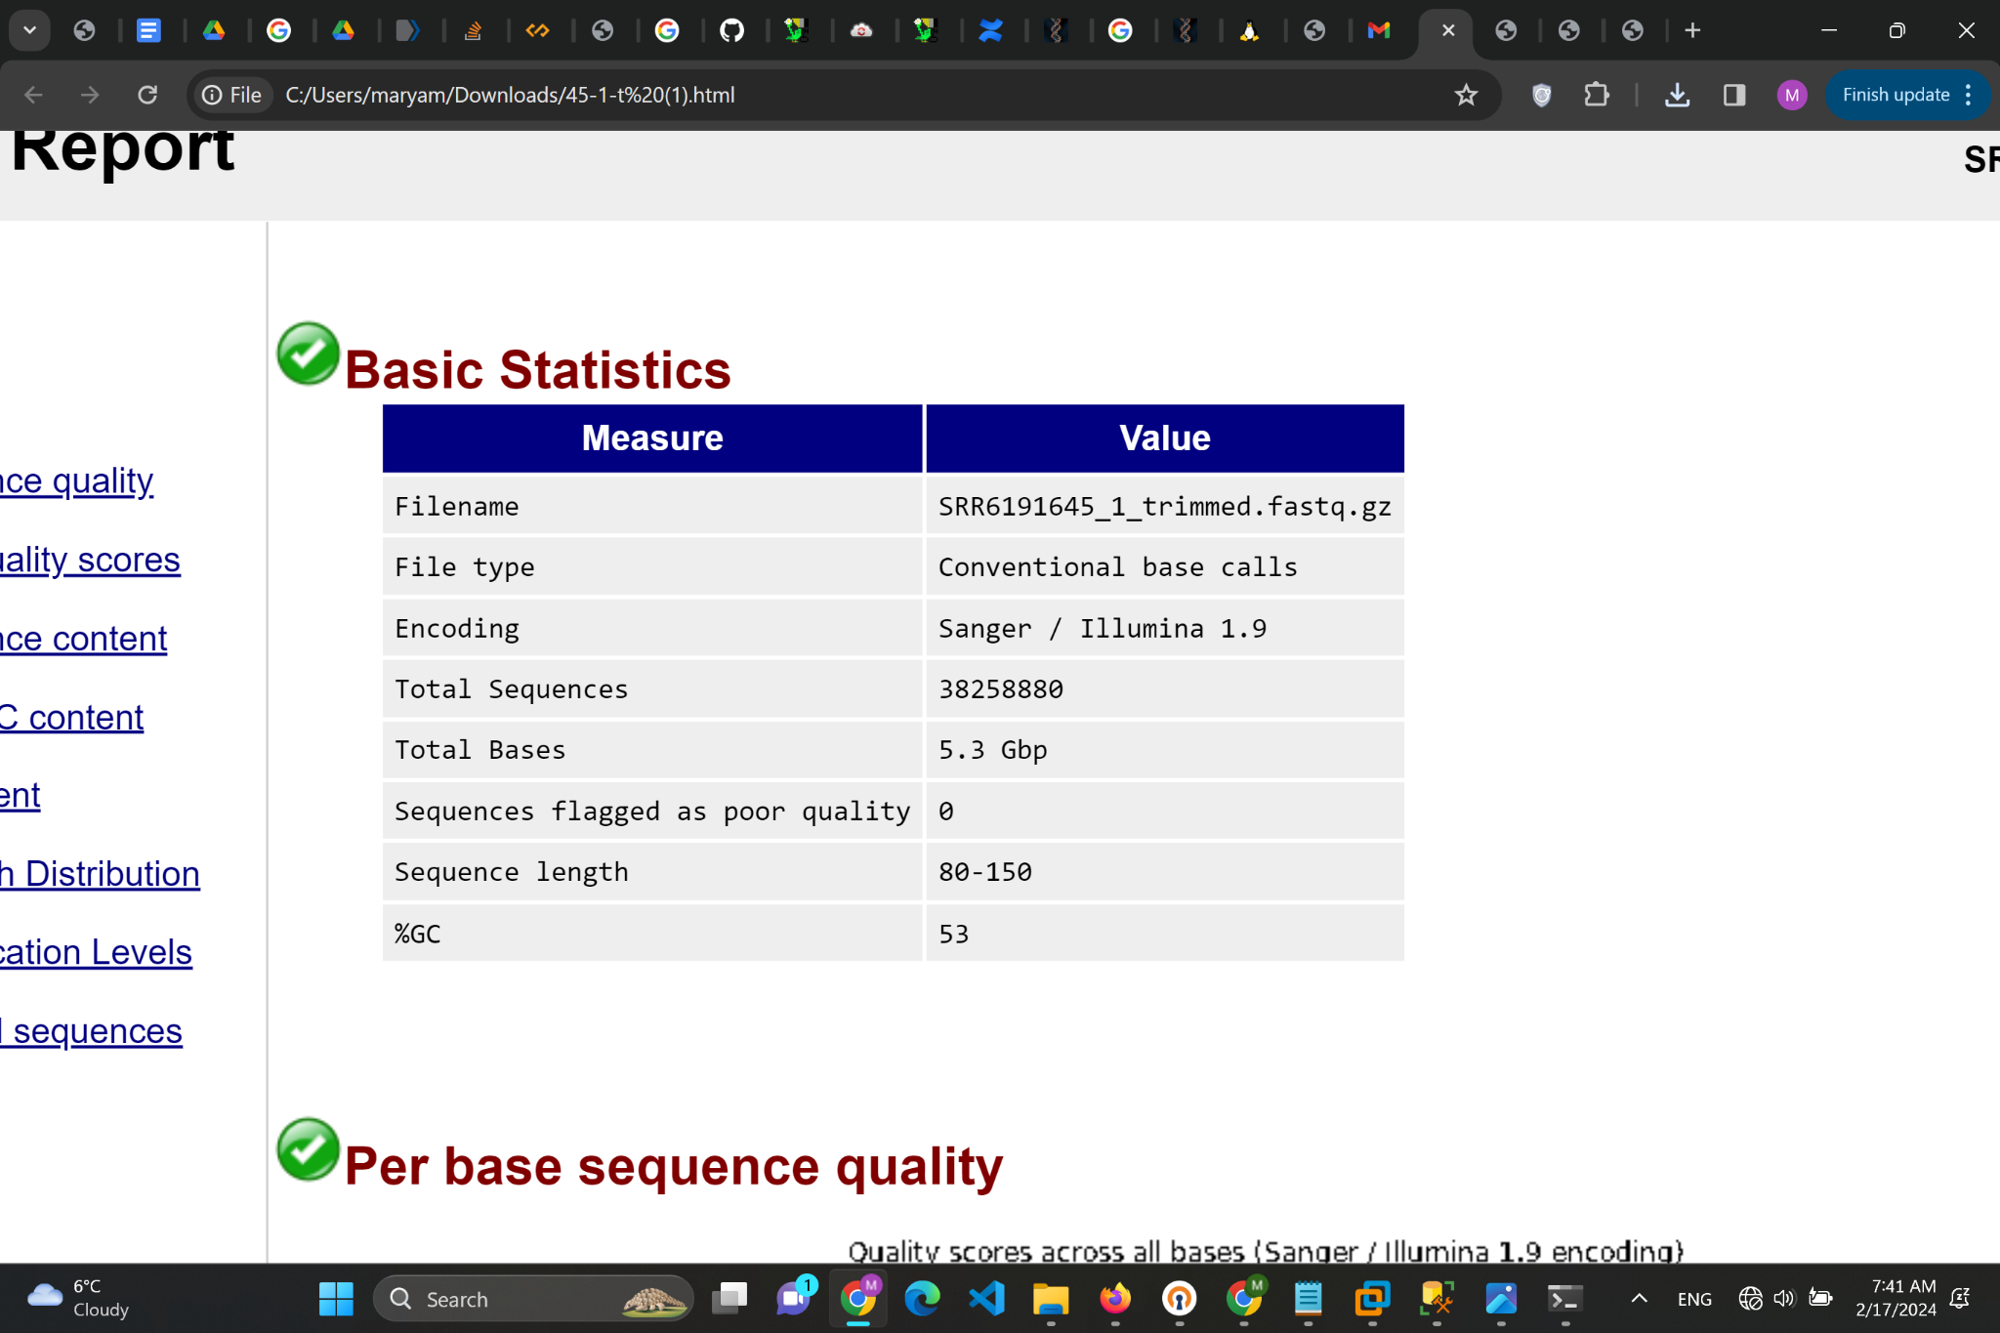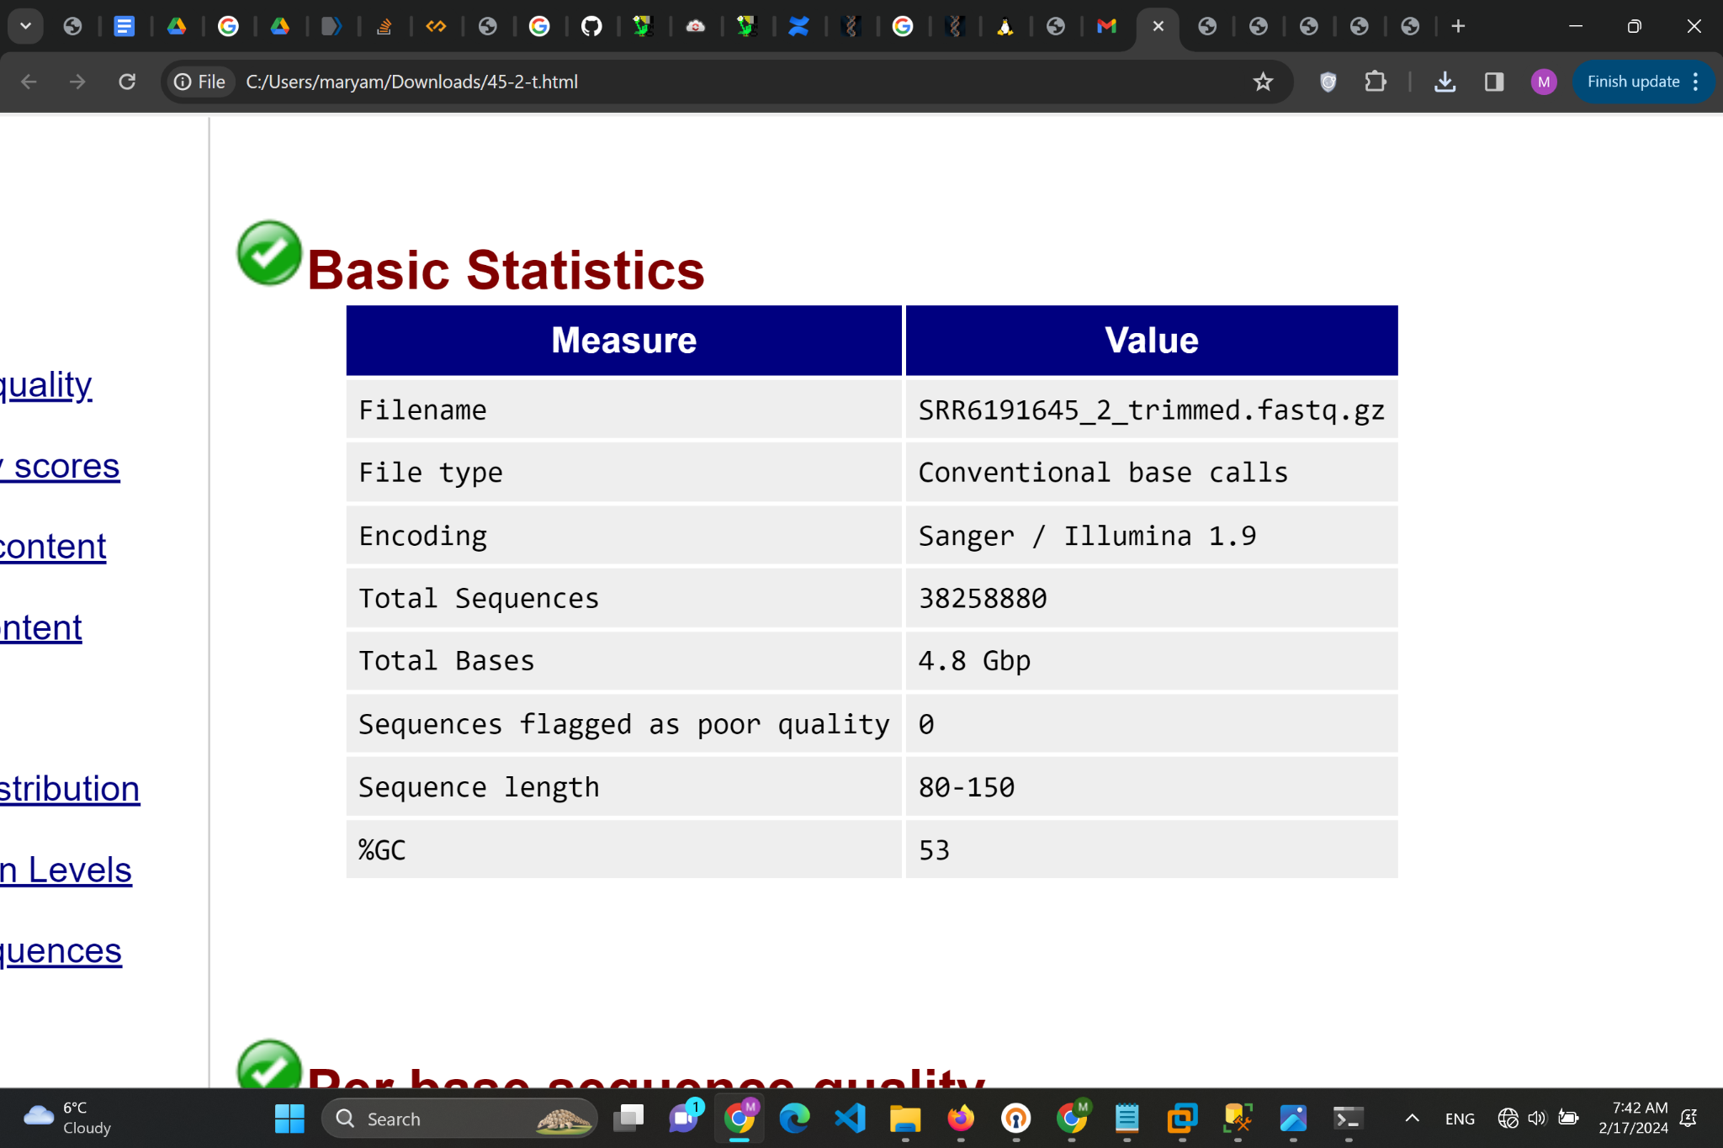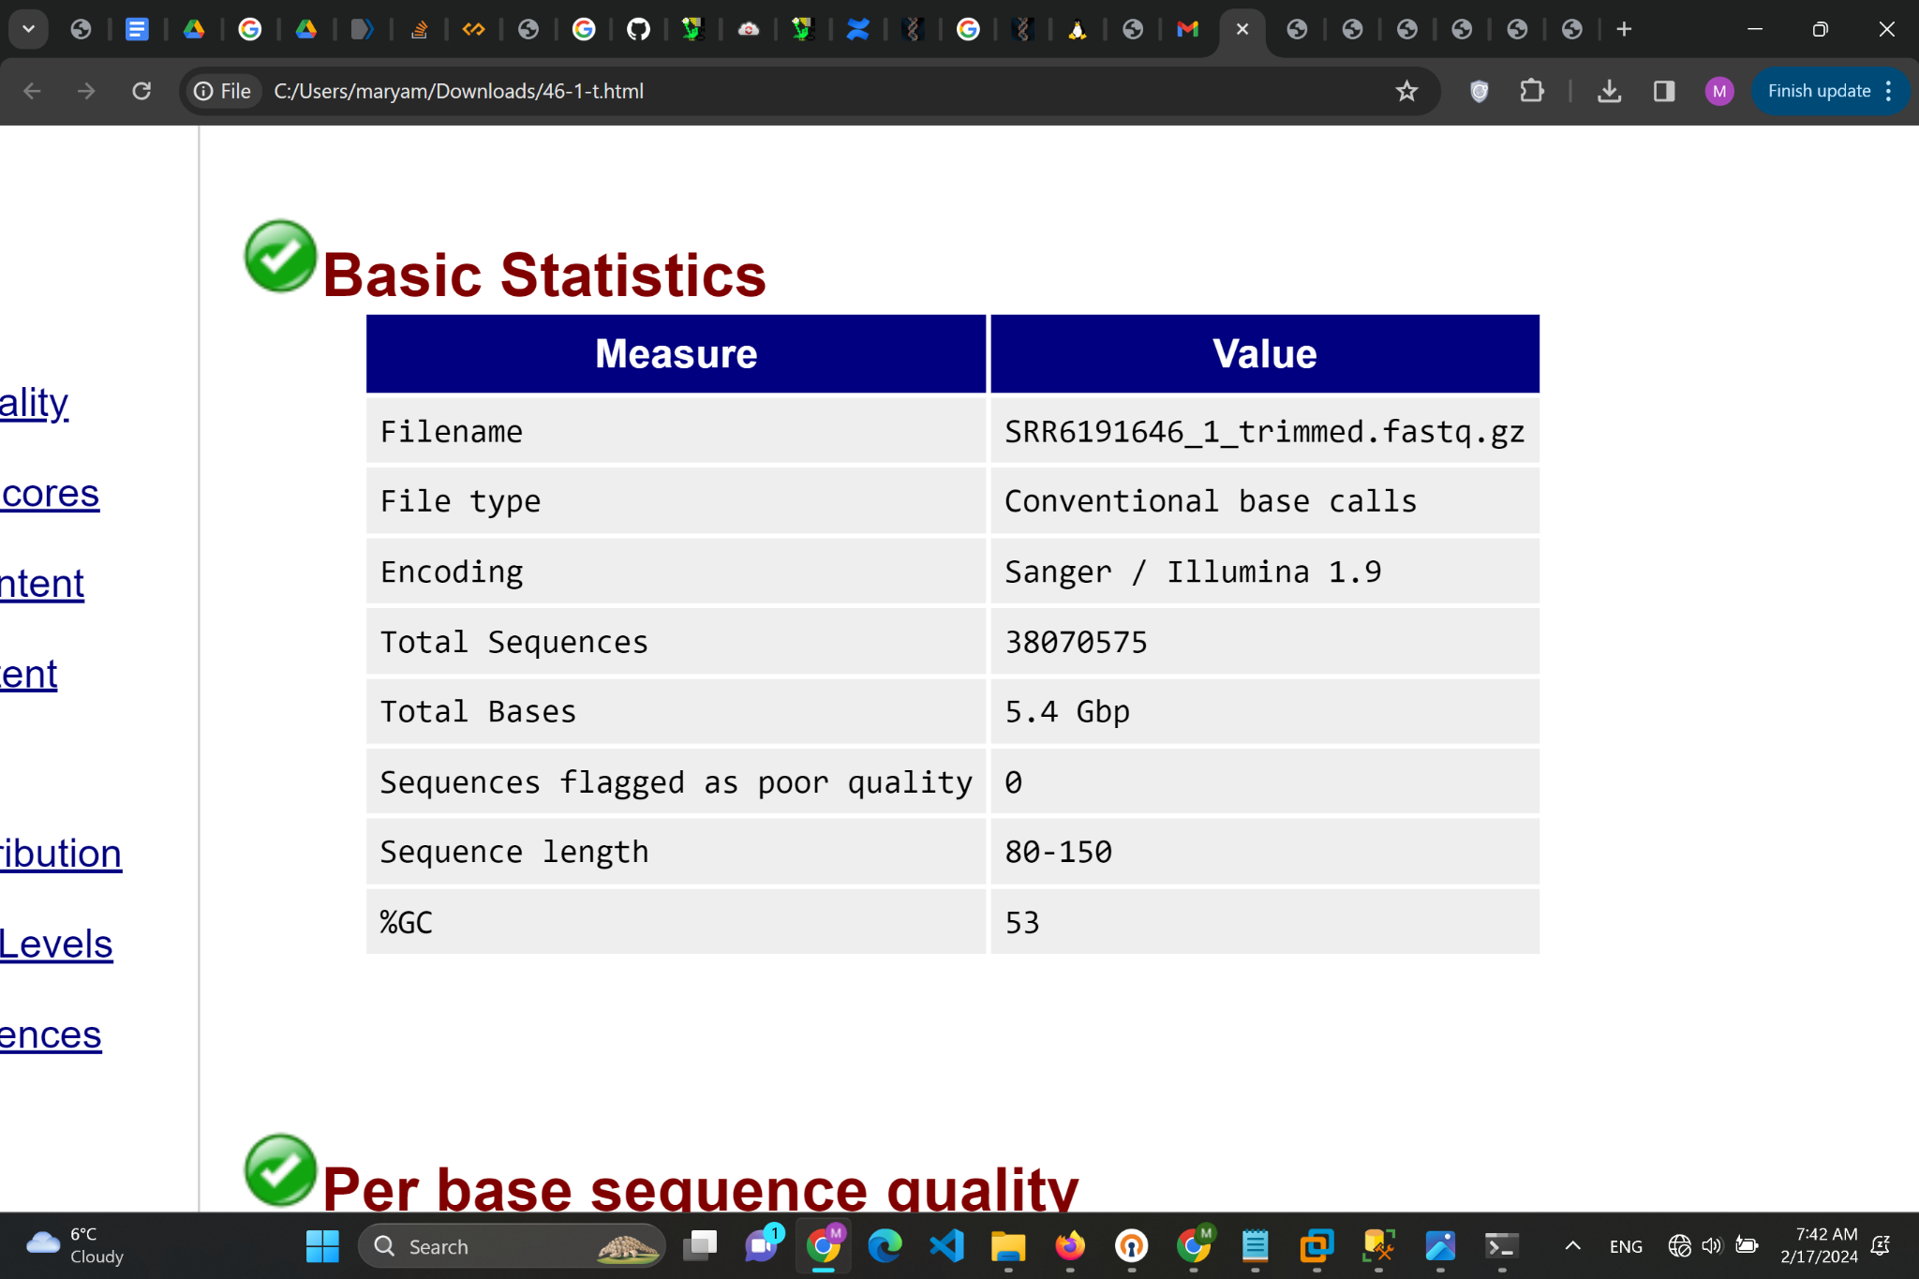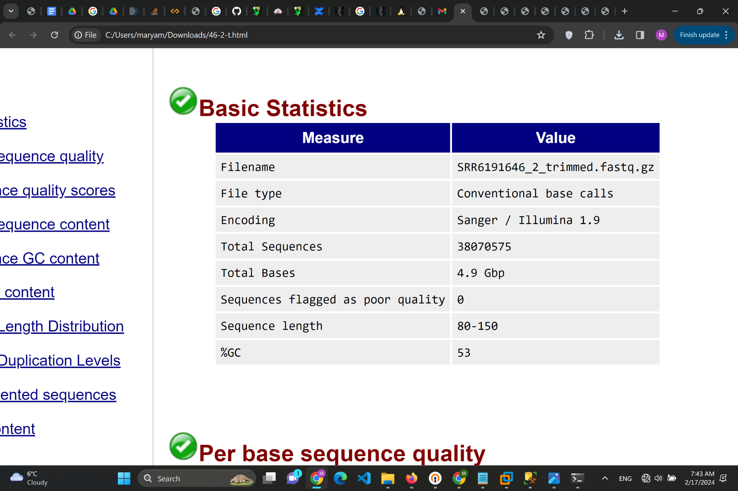

# Calculating the average number of sequences (reads) for SRR645 before and after trimming.

# Number of reads before trimming

reads_before_45_1 = 64135799

reads_before_45_2 = 64135799

# Number of reads after trimming

reads_after_45_1 = 38258880

reads_after_45_2 = 38258880

# Calculate the average average_before_trimming = (reads_before_45_1 + reads_before_45_2) / 2

average_after_trimming = (reads_after_45_1 + reads_after_45_2) / 2

Average_before_trimming = 64135799.0

Average_after_trimming = 38258880.0

# Total sequences before trimming

total_before_trim_46_1 = 57973670

total_before_trim_46_2 = 57973670

# Total sequences after trimming

total_after_trim_46_1 = 38070575

total_after_trim_46_2 = 38070575

# Calculate averages

average_before_trim_646 = (total_before_trim_46_1 + total_before_trim_46_2) / 2

average_after_trim_646 = (total_after_trim_46_1 + total_after_trim_46_2) / 2

Average_before_trim_646 = 57973670.0

average_after_trim_646 = 38070575.0

2. Compare the read length averages in different samples before and after the read

trimming?

For all of them 150 before trimming and after trimming between 80 to 150.

3. Compare the read quality distributions over all sequences before and after the read

Trimming.

1. Before Trimming:

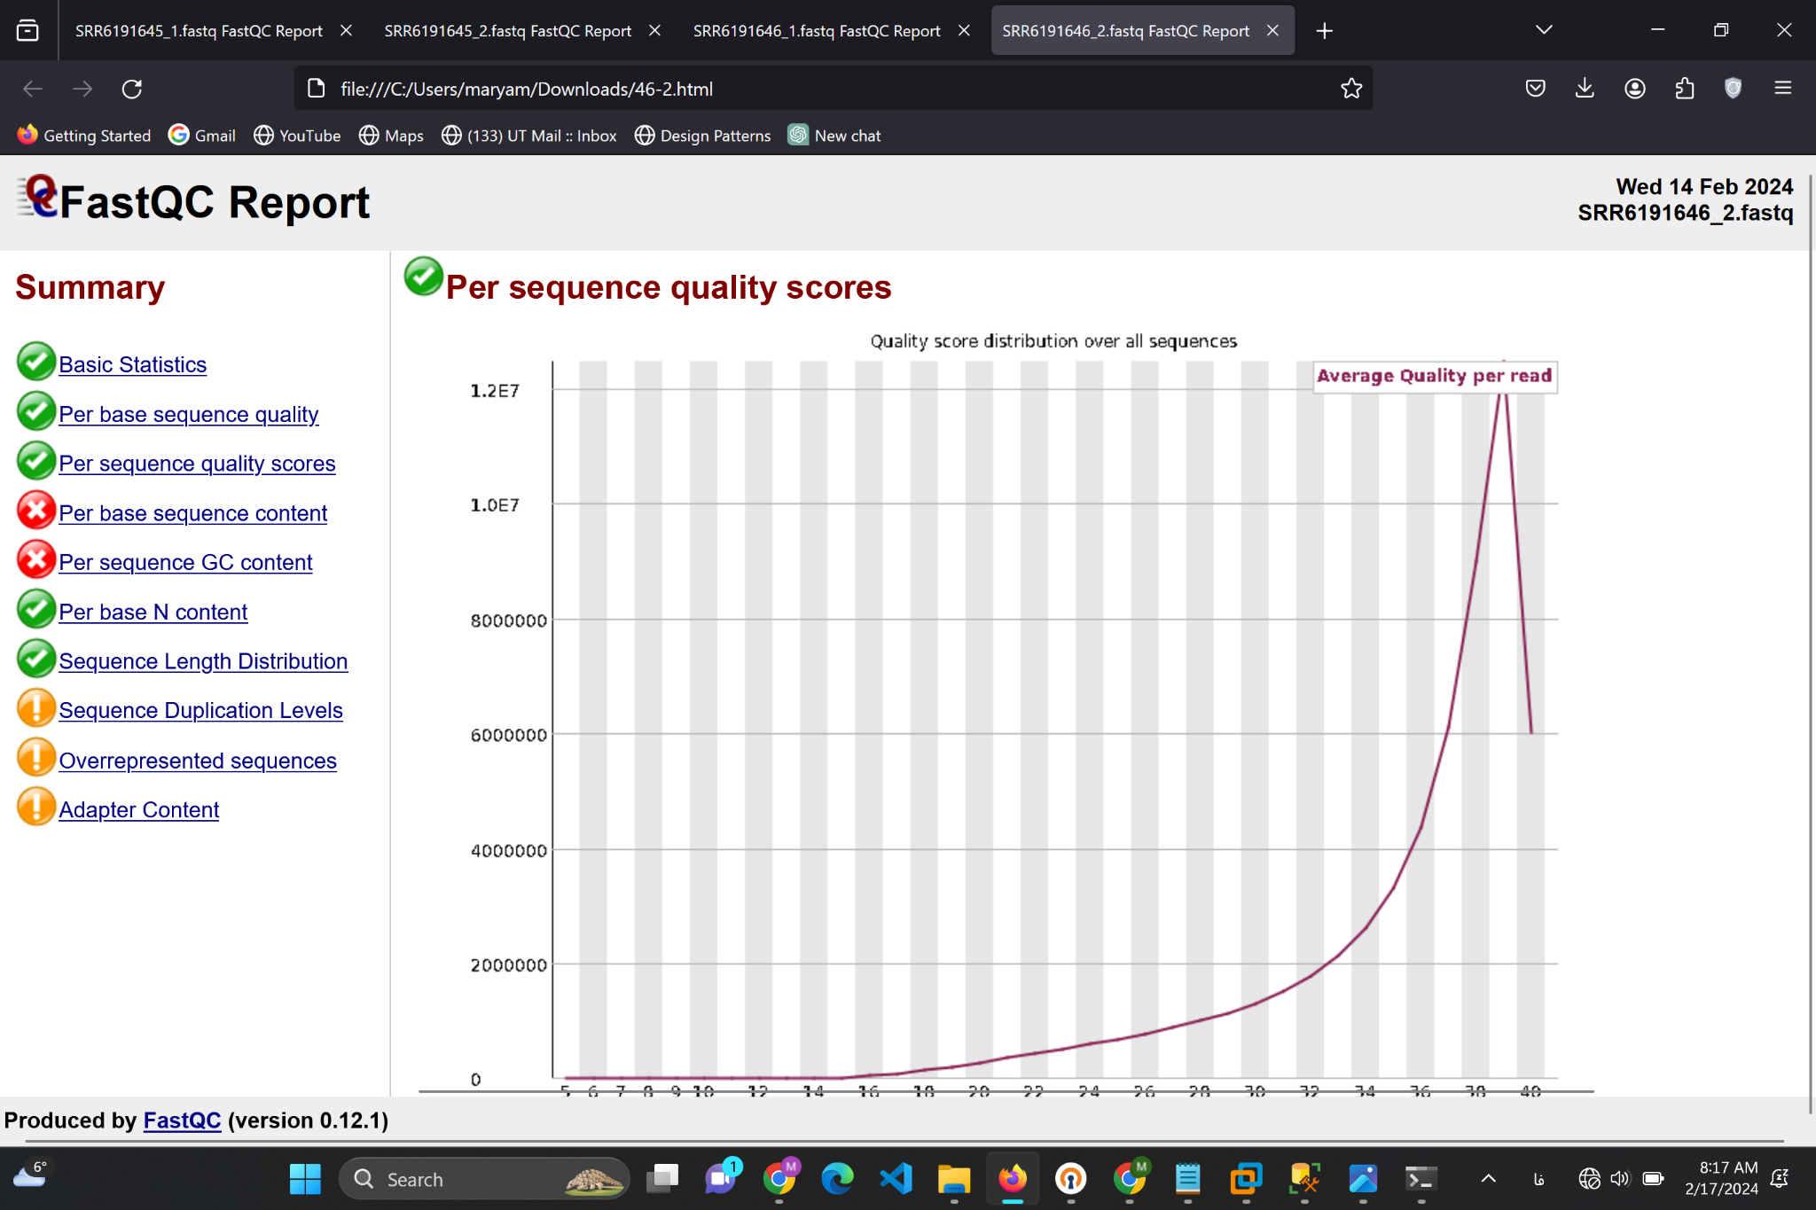

The quality score distribution chart shows that most sequences have high-quality scores (above 30), which is generally considered good. The peak of the distribution is at the highest quality score, suggesting that the majority of the sequences are of very high quality.

2. After Trimming :

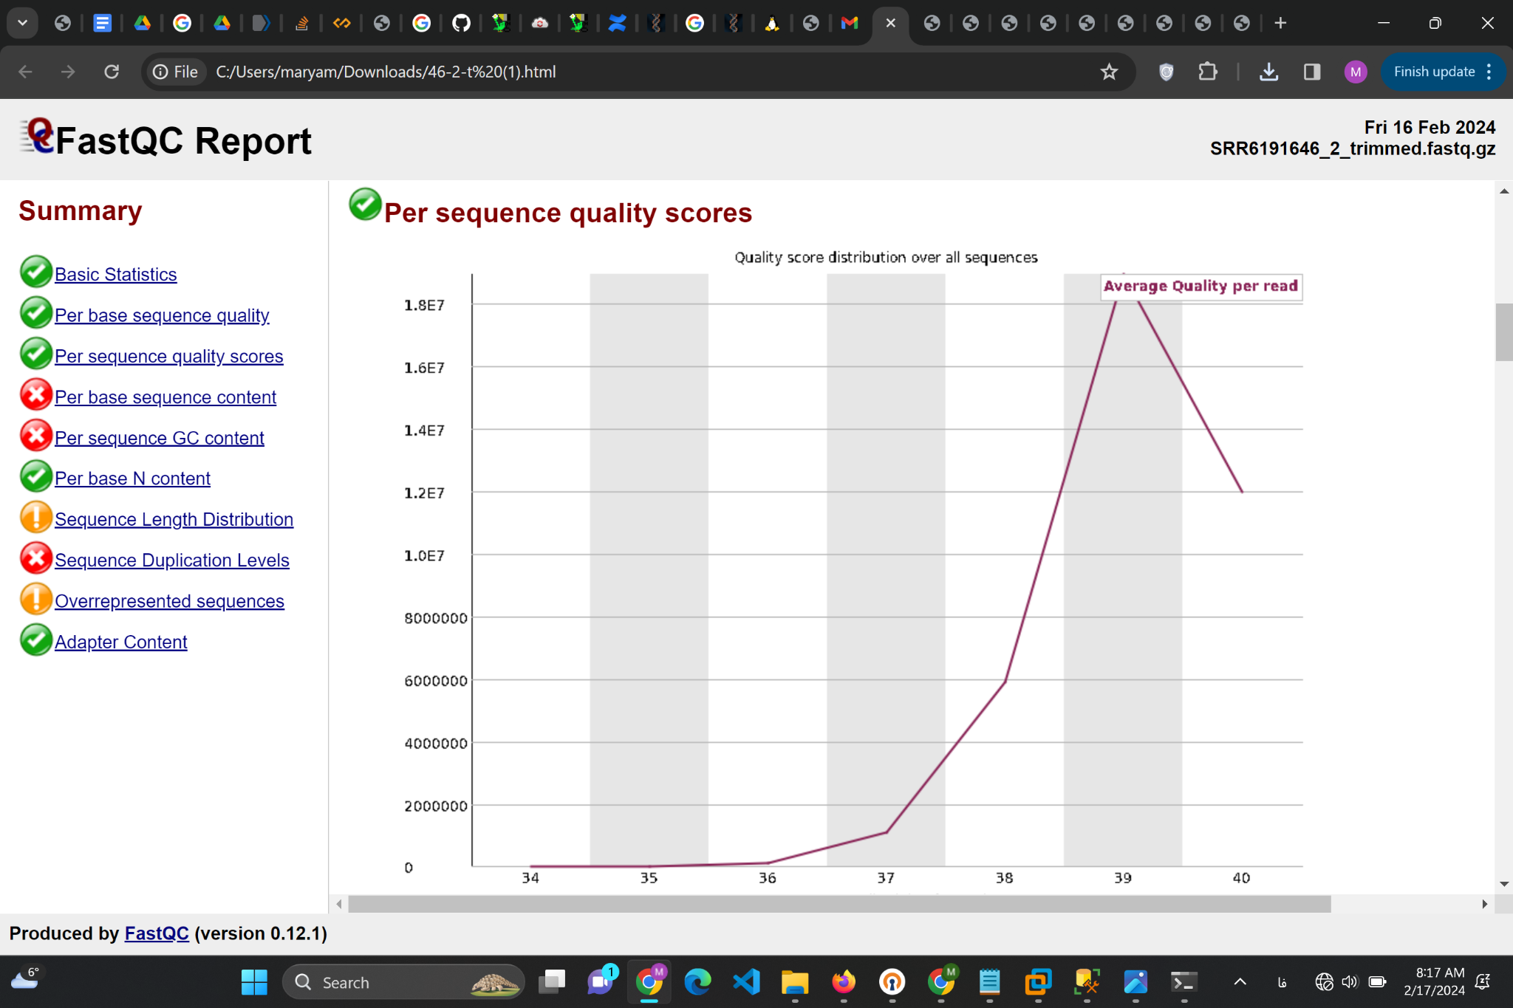

The post-trimming quality score distribution chart also shows that most sequences have high-quality scores, with the peak of the distribution at the highest quality score. This suggests that trimming has maintained or even slightly improved the overall quality score distribution

4. What does the Adaptor Content warning indicate?

Adapter Content Checks, if the reads in the FASTQ file, contain a significant amount of adapter sequences. If an adapter sequence is present in more than 5% of all reads the result will be 'warning'. If more than 10% are present the result will be 'failed'.

5. Why do we first remove the Adapter sequences for the reads and then the low-quality

bases?

1. Identification and Accuracy: Adapter sequences are known and specific sequences that do not vary much between reads. It's easier to accurately identify and remove these sequences first because their presence is not affected by the quality of sequencing. In contrast, the identification of low-quality bases can somewhat depend on the context of the surrounding bases, which might be influenced by adapter sequences if they are still present.
2. Efficiency of Subsequent Steps: Removing adapter sequences first simplifies the sequence data, making it more straightforward to assess the quality of the remaining sequence data. This can make the subsequent trimming of low-quality bases more efficient and accurate, as the algorithms can focus on the real biological sequences without interference from adapter sequences.
3. Avoiding False Trimming: If low-quality base trimming is performed first, there's a risk that the algorithm might mistakenly trim parts of the adapter sequence that happen to have high-quality scores. This would leave fragments of adapter sequence in the data, which could interfere with downstream analysis (e.g., alignment to a reference genome or transcriptome), because these adapter fragments could be misaligned or cause the reads to be aligned incorrectly.
4. Maximizing Useful Data: By removing adapter sequences first, you ensure that the trimming of low-quality bases is only applied to the actual biological sequences of interest. This maximizes the amount of useful, high-quality biological data available for downstream analysis. If you were to trim low-quality bases before removing adapters, you might unnecessarily lose more of the biological sequence in the process.

6. What does the quality of bases mean, and how is it obtained?

The quality of bases in the context of DNA or RNA sequencing refers to a measure of confidence in the accuracy of each nucleotide base call made by the sequencing platform.

Quality scores are usually expressed on a Phred scale, which is a logarithmic scale. The Phred quality score, Q, is defined as:

Q = $-10×log_{10}P$

Where P is the probability that the base call is incorrect.

Illumina systems create a quality score in three steps. First of all it evaluates the detected light signal for each base call for every cluster, on every tile, for every sequencing cycle simultaneous with a sequencing run. Thereby it measures various aspects correlating with the quality of the base call like single-to-noise ration and light intensity (1). Based on these parameters a quality predictor value (QPV) is calculated. In the second step the QPV has to be translated into a quality score with the help of a quality table. The Q-table based on a statistical calibration curve derived from empirical data including various well-characterized human and not-human samples mostly using a version of the so-called Phred algorithm (1). That is why the score is also called Phred quality score. In the last step the quality score (per cycle) is recorded common with the base call in a base call file (.bcl) which is later converted to FASTQ files (.fastq).

**Part B**

First i downloaded reference genome:

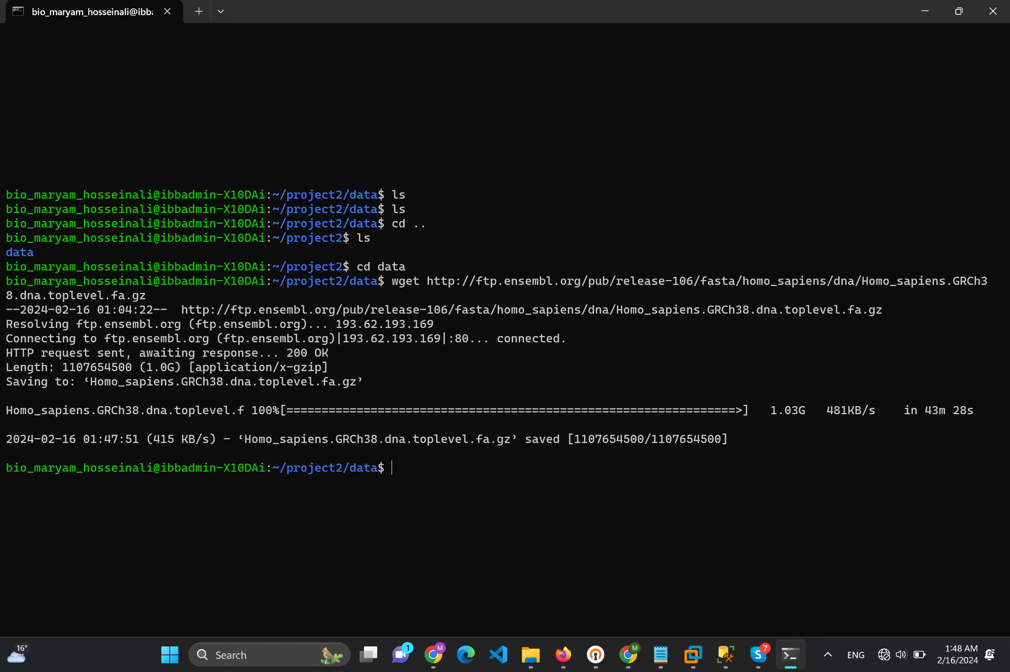

Then i unzipped it:

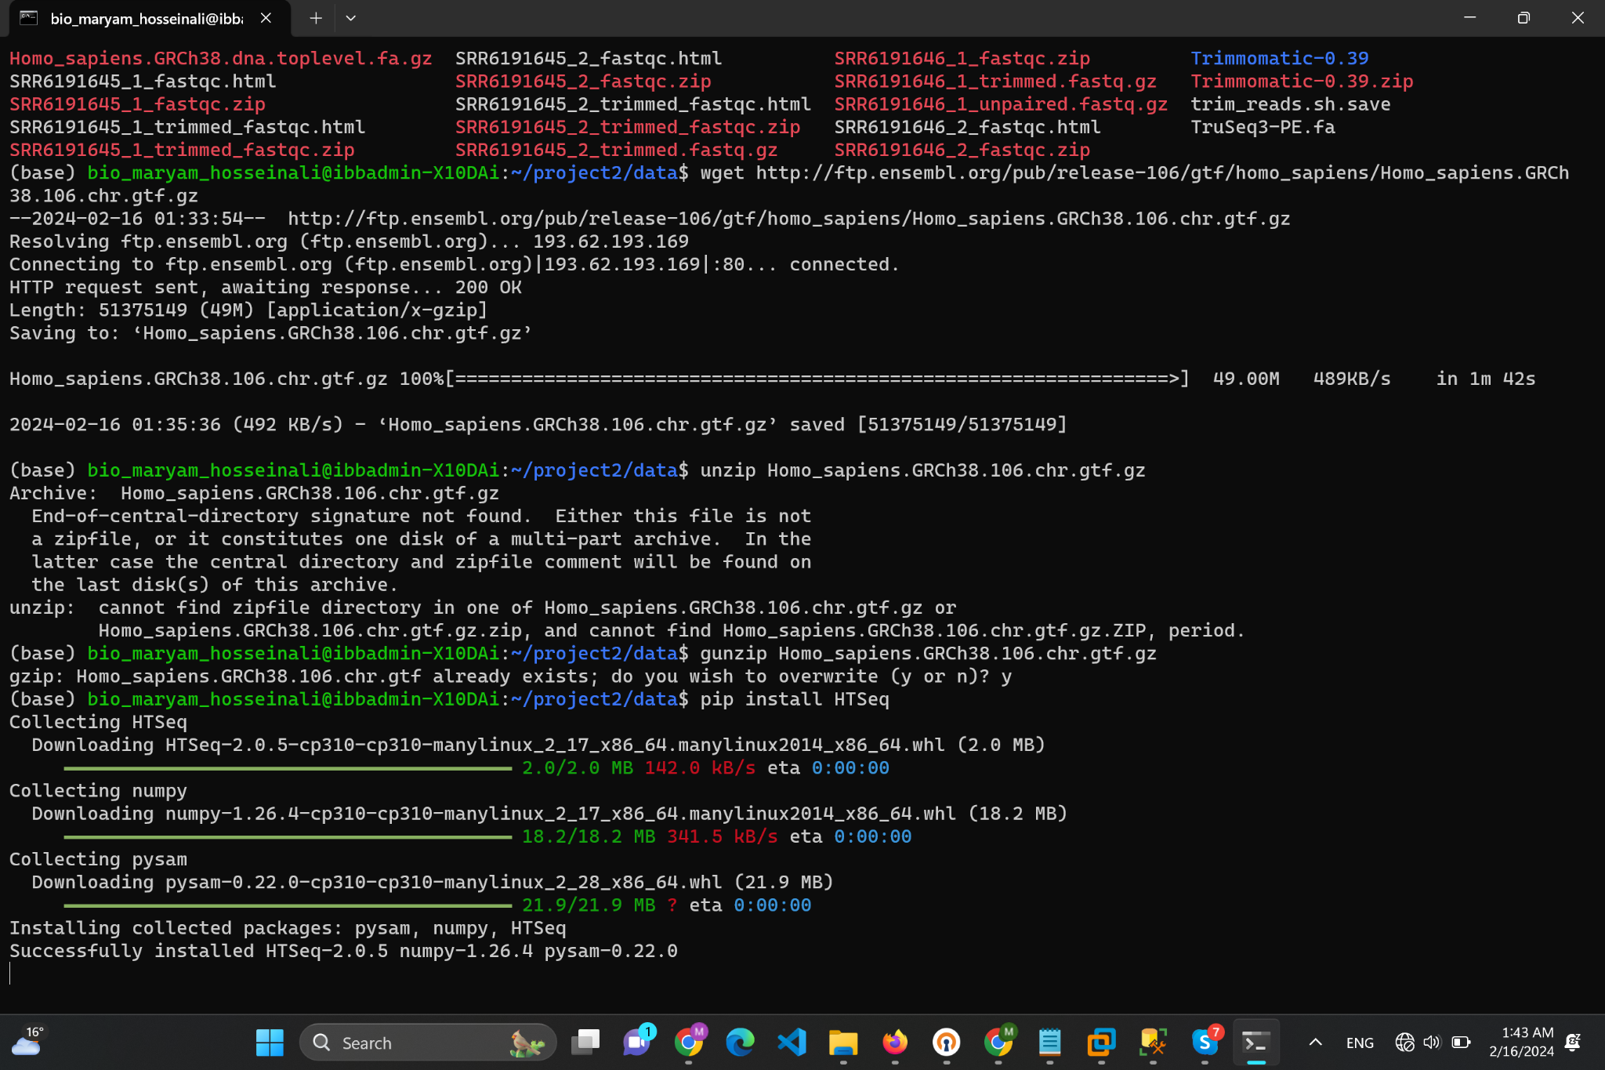

Then i indexed reference genome:

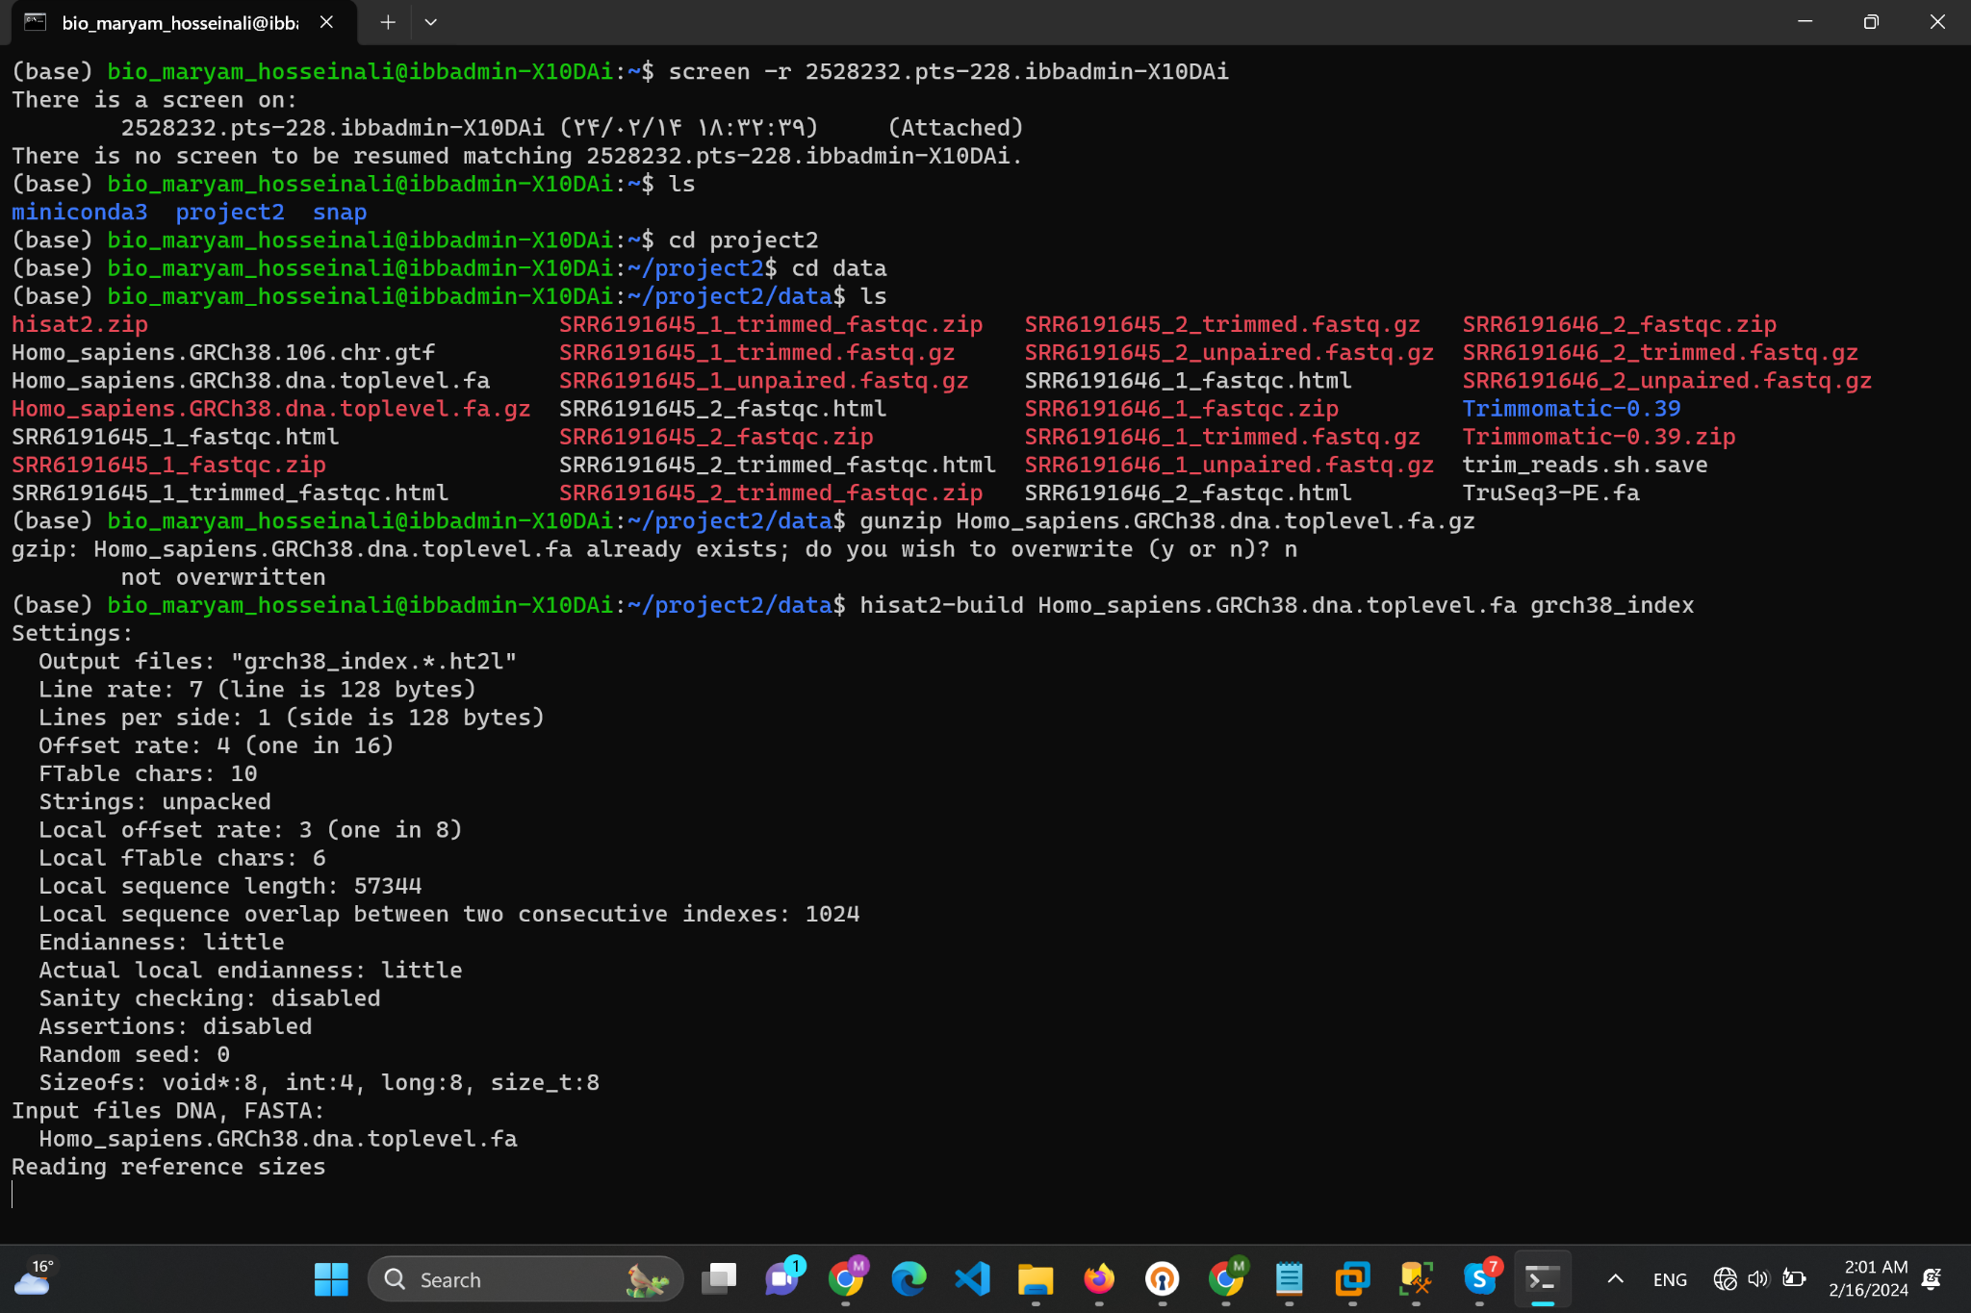

After a long time 8 indexes appeared:

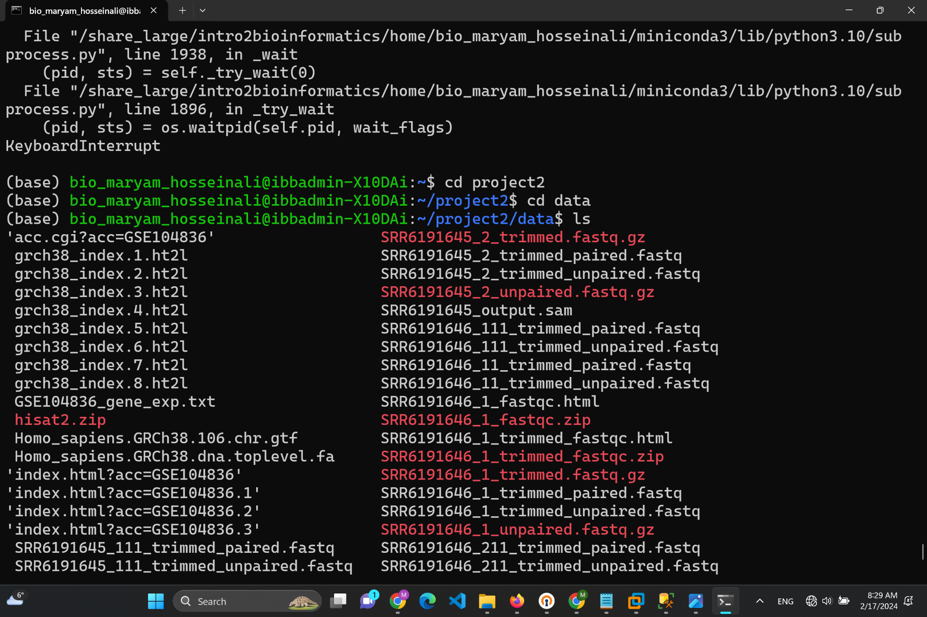

I used command below to get .sam file but unfortunately it has not finished yet…

hisat2 -x ./grch38_index -1 /share_large/intro2bioinformatics/data/fastq/SRR6191645_1.fastq -2 /share_large/intro2bioinformatics/data/fastq/SRR6191645_2.fastq -S SRR6191645_output.sam

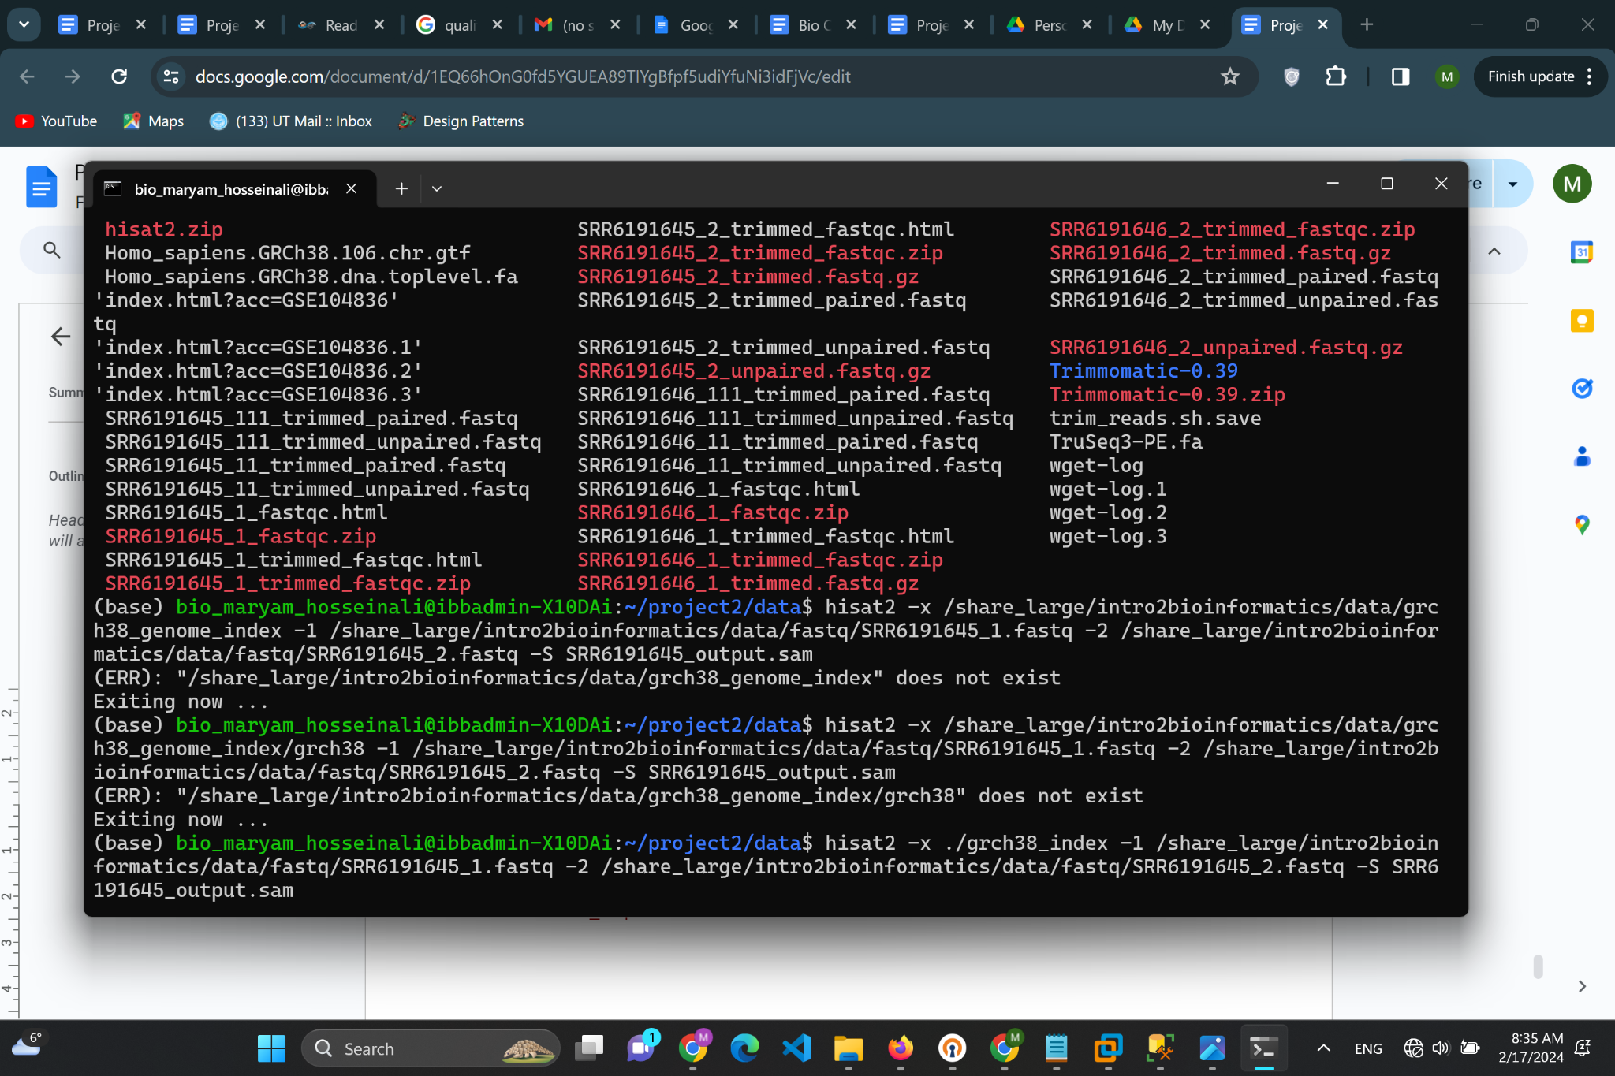

I also know the next steps but .sam file was needed.

samtools view -Sb SRR6191645_output_alignment.sam >

SRR6191645_output_alignment.bam

samtools sort SRR6191645_output_alignment.bam -o

SRR6191645_output_alignment_sorted.bam

samtools index SRR6191645_output_alignment_sorted.bam

Above command will produce .bam files.

1. What is the difference between SAM and BAM files?

SAM files are a type of text file format that contains the alignment information of various sequences that are mapped against reference sequences. These files can also contain unmapped sequences. SAM files are a text file format, so they are more readable by humans.

BAM files contain the same information as SAM files, except they are in binary file format which is not readable by humans. On the other hand, BAM files are smaller and more efficient for software to work with than SAM files, saving time and reducing costs of computation and storage. Alignment data is almost always stored in BAM files and most software that analyzes aligned reads expects to ingest data in BAM format.

2. What is the purpose of indexing the genome?

It is a computational strategy known as ‘indexing’ to speed up the mapping algorithms. Like the index at the end of a book, an index of a large DNA sequence allows one to rapidly find shorter sequences embedded within it and make the queries fast.

**Part C**

Unfortunately since i could not generate the bam files on time this part could not be done but its command is as follows:

htseq-count -f bam -r pos -s no -i gene_id -t exon

SRR6191645_output_alignment_sorted.bam Homo_sapiens.GRCh38.106.chr.gtf >

counts_SRR6191645.txt

3. What are other software available to do this step? Name two other software and discuss

their advantages and disadvantages.

**DESeq** uses a similar negative binomial model as edgeR but models the observed relationship between the mean and variance when estimating dispersion, allowing a more general, data-driven parameter estimation. According to the method developers, this allows a balanced selection of differentially expressed genes throughout the dynamic range of the data. Similar to edgeR, a scaling factor normalization procedure is carried out to account for the varying sequencing depths of the different samples, and the Benjamini–Hochberg procedure is used to control the FDR. Also, DESeq has been developed to enable the analysis of experiments with small numbers of replicates. With DESeq, it is technically possible, although not recommended, to work with experiments without any biological replicates.

**NOIseq** is a data-adaptive non-parametric method, that empirically models the noise distribution from the actual data by contrasting fold-change differences and absolute expression differences among samples within the same condition. According to the method developers, it can therefore adapt to the size of the data set and thus efficiently control the rate of false discoveries. NOIseq includes RPKM (reads per kilobase per million mapped reads) as a default normalization method. The package is specifically designed to account for small numbers of replicates and genes with low expression levels.

**Part D**

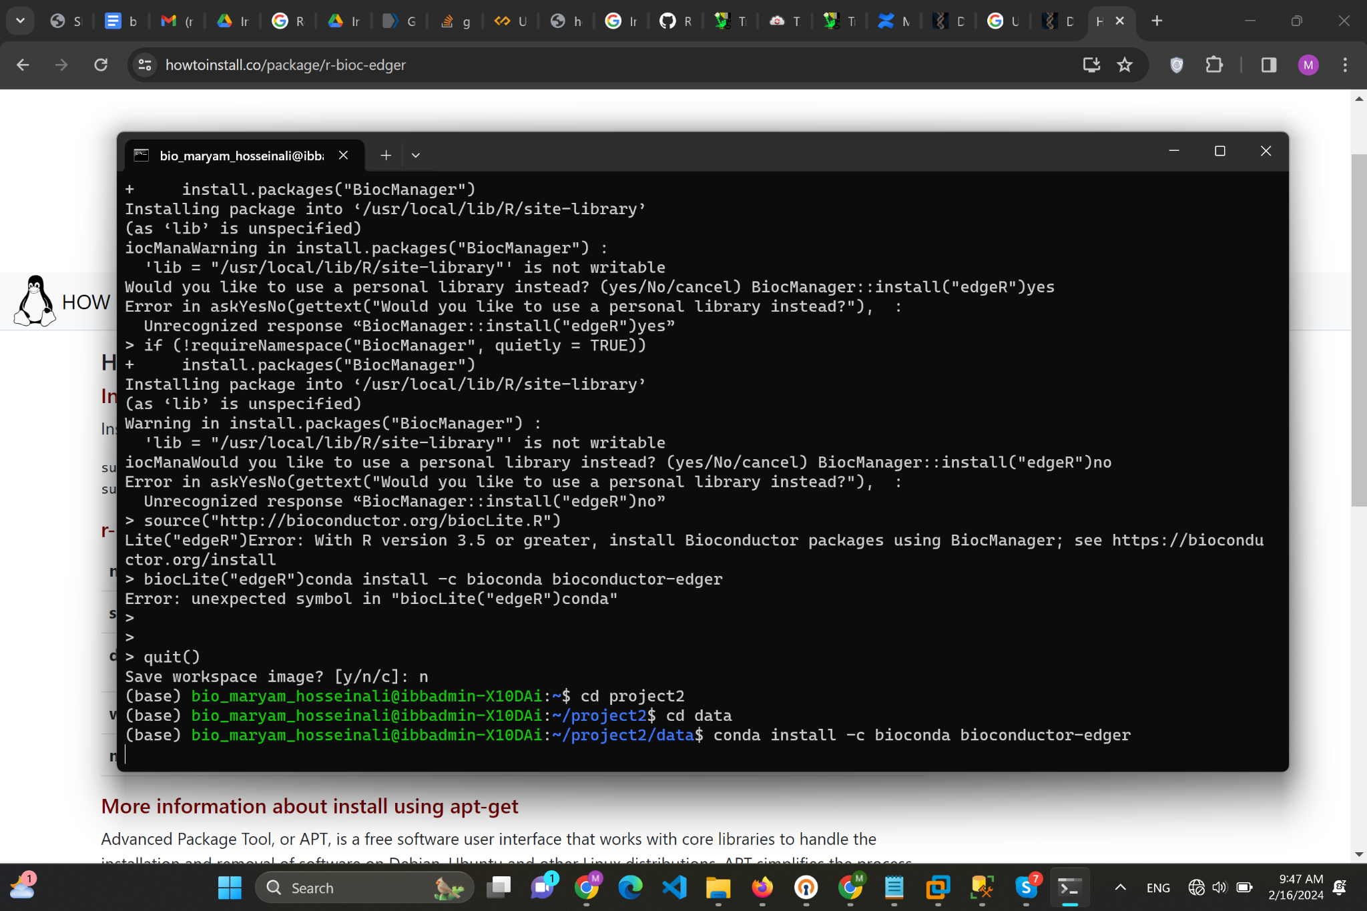

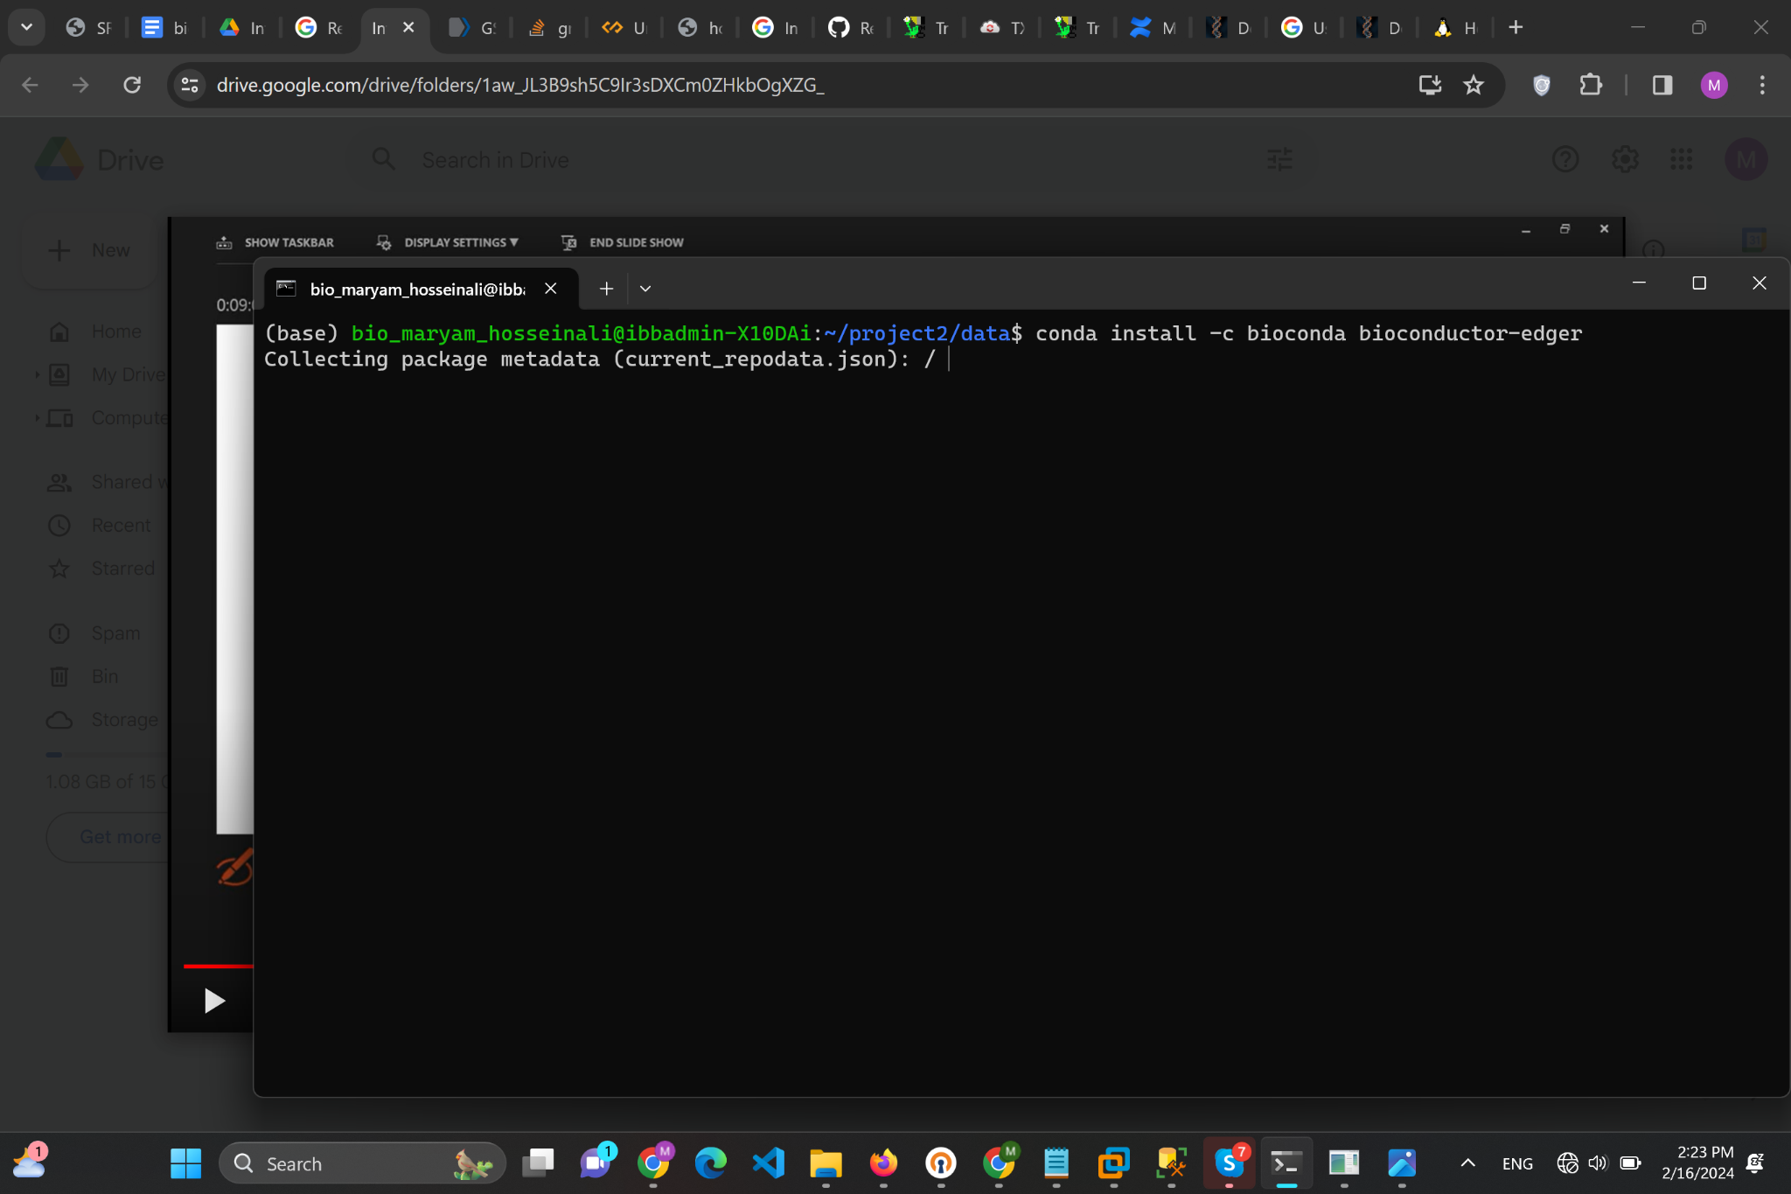

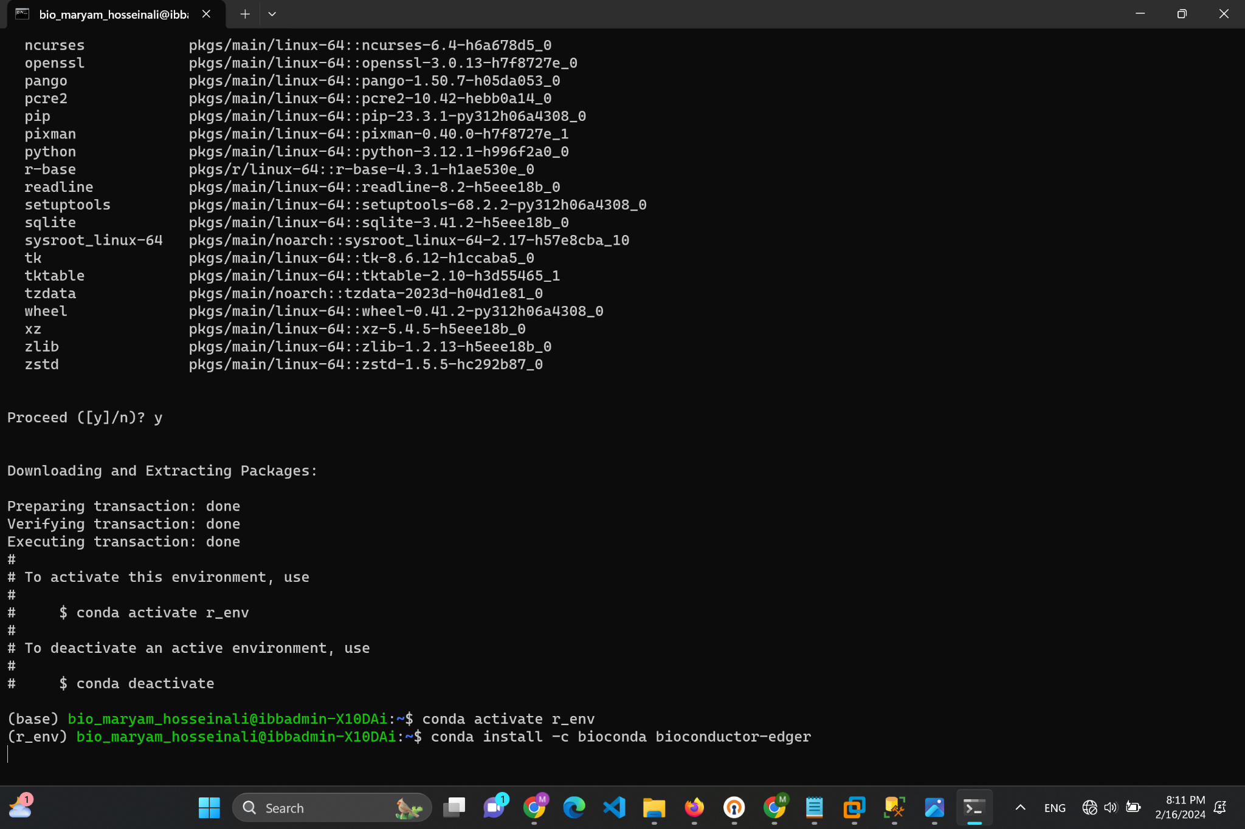

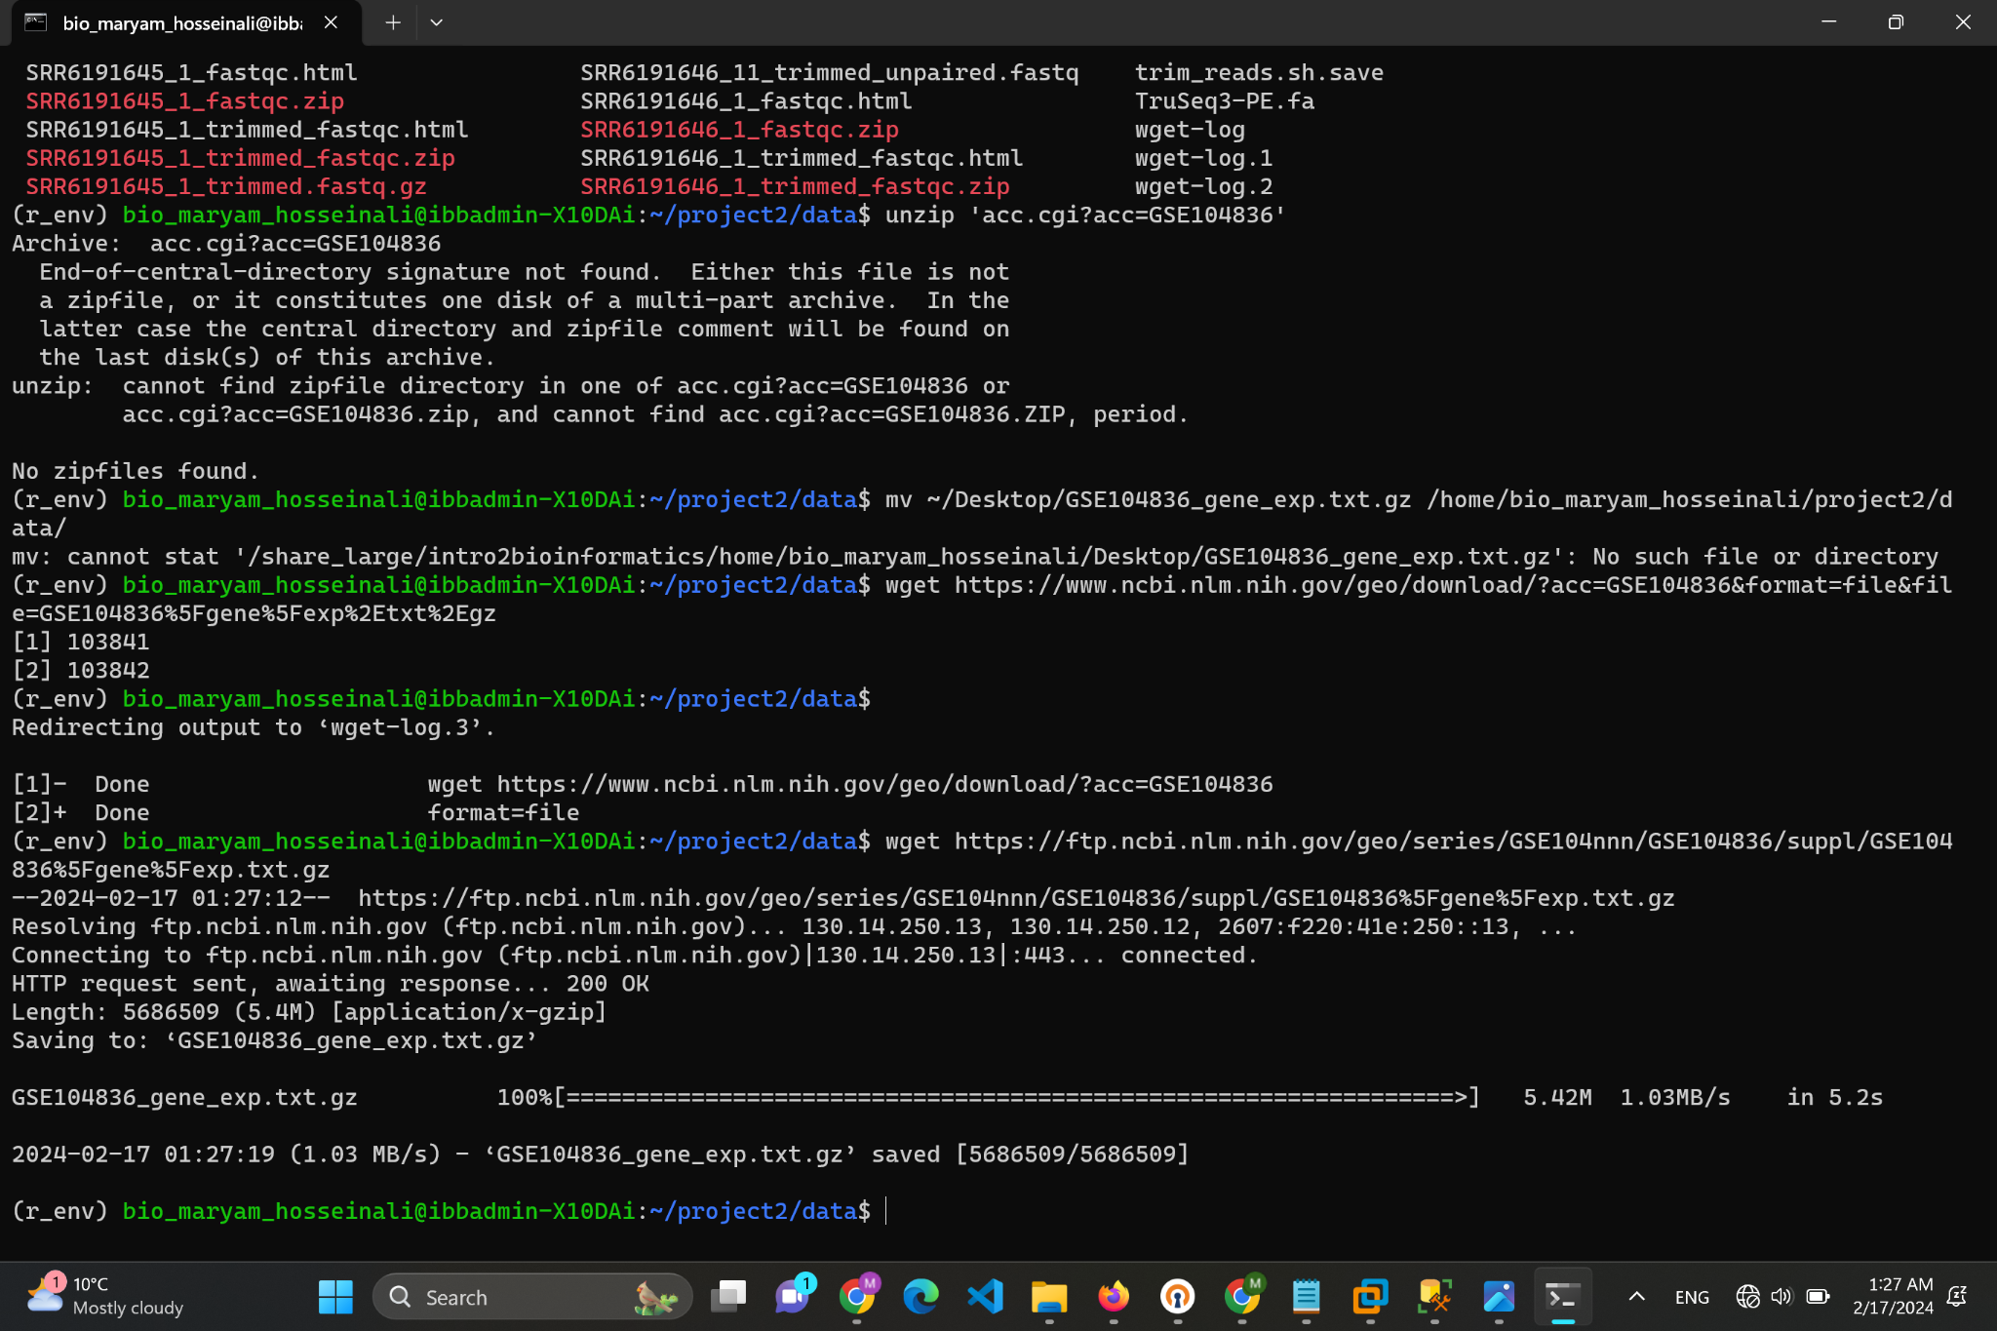

After downloading .txt file, i unzipped it

I ran commands below to do a differential expression analysis comparing two groups using the edgeR:

1. Prepare the data: You read your gene expression data into R, created a `DGEList` object, and filtered out the lowly expressed genes with `filterByExpr`.

2. Normalization: You normalized the read counts using `calcNormFactors` to account for compositional differences between the libraries.

3. Dispersion estimation: You estimated the dispersion of counts with `estimateDisp`, which edgeR uses to model the variability of counts for each gene.

4. Running the test: You ran `exactTest`, which performs pairwise comparisons between two groups (in your case, "N" for normal and "C" for cancerous samples) to find differentially expressed genes.

5. Extracting results**: The `topTags` function was used to extract the top differentially expressed genes from the test results.

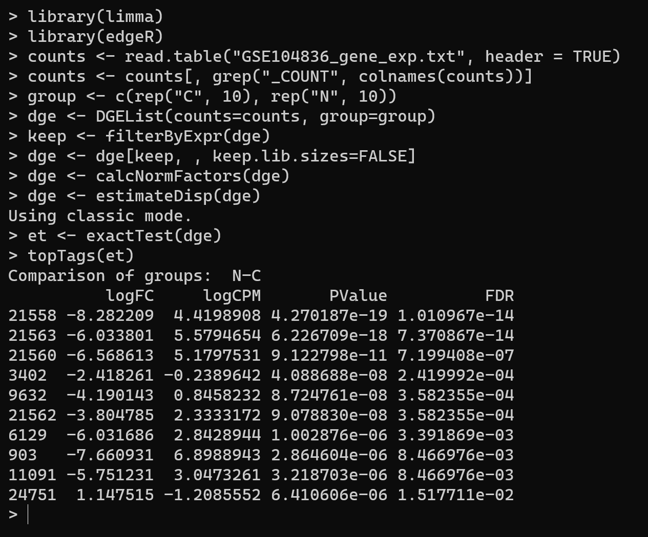

The output table components:

- **LogFC** (log2 fold change): The log-ratio of expression between groups. Negative values indicate downregulation in the "N" group relative to the "C" group, while positive values indicate upregulation.

- **logCPM** (log counts per million): A measure of the overall expression level of each gene.

- **PValue** The p-value representing the probability that the observed difference in expression could be due to random chance. Smaller values indicate stronger evidence against the null hypothesis (no difference).

- **FDR** (False Discovery Rate): The adjusted p-value which accounts for multiple testing. It is the expected proportion of false positives among the list of differentially expressed genes.

For example, the first gene (ID 21558) shows a significant downregulation in the "N" group with a log2 fold change of approximately -8.28, meaning it's highly expressed in cancer compared to normal samples.

results table shows the top genes with the most significant changes in expression between the two groups. The **FDR values** indicate the confidence in these results being true positives, with lower values suggesting higher confidence. Generally, an FDR below 0.05 is considered statistically significant for differential expression.

Will answer questions of this part based on the image i provide earlier and the image below:

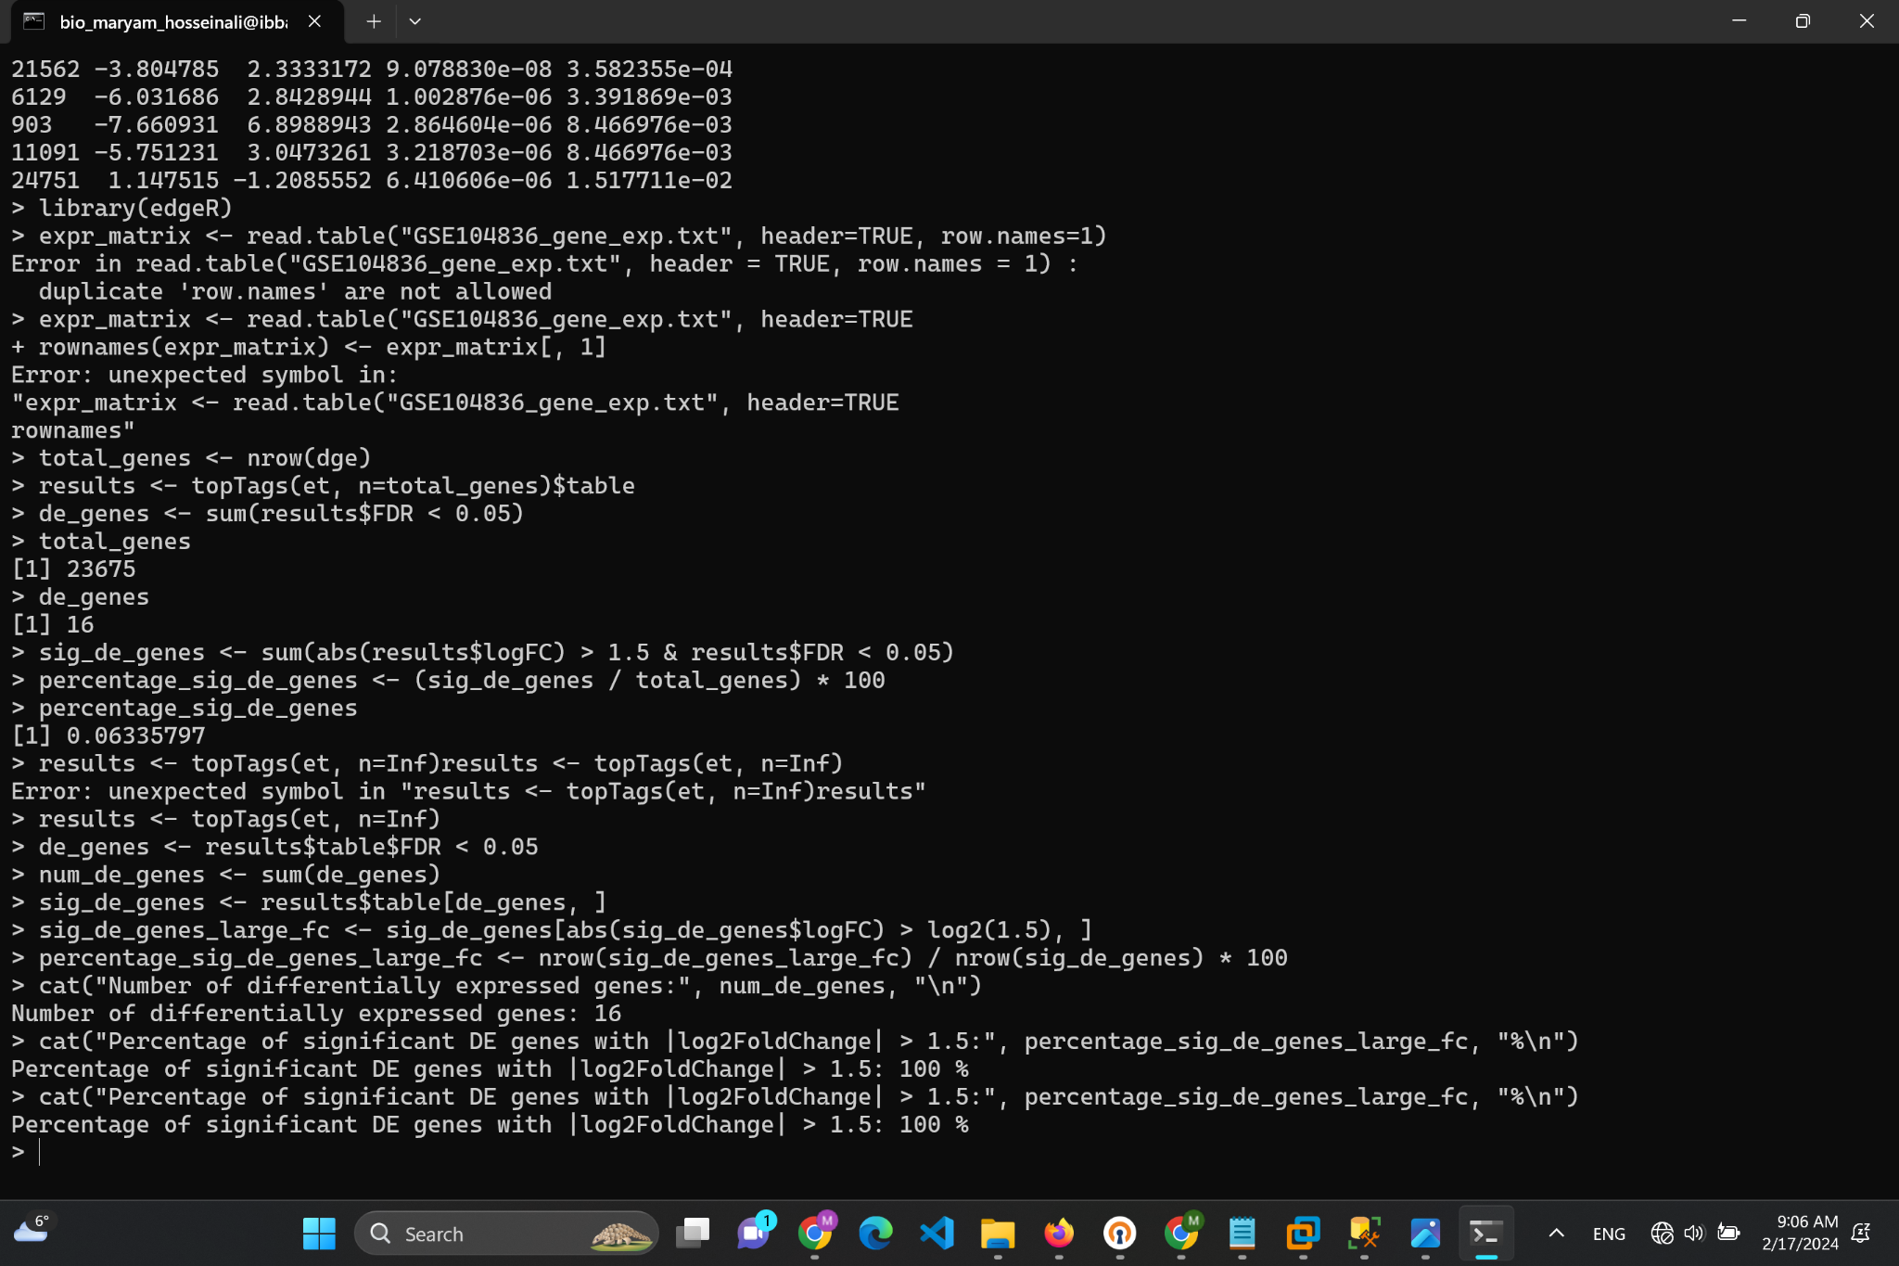

1. How many genes are given to edgeR? How many of them are differentially expressed in

tumor versus normal samples? How do you define statistical significance in this context?

Based on the image we can see total genes are 23675

By applying a threshold to FDR value, which is commonly set at <0.05 for statistical significance, based on the image we can see 16 genes differentially expressed genes.

2. Determine the percentage of differentially expressed genes with |log2FoldChange| > 1.5.

Based on the image we obtained a result of 100% for the percentage of significant differentially expressed (DE) genes with an absolute log2 fold change greater than 1.5, it means that every gene that was determined to be differentially expressed based on the FDR threshold also meets the criteria of having an absolute log2 fold change greater than 1.5.

3. Explain the difference between P-value and FDR?

There are 3 fundamental differences between p-value and FDR:

* Context of Use: The p-value is used to evaluate the evidence against the null hypothesis in both single and multiple testing scenarios. FDR, on the other hand, is specifically designed to address the issue of multiple comparisons and control the expected rate of false discoveries.
* What They Measure: The p-value measures the probability of observing the given result (or more extreme) assuming the null hypothesis is true. FDR measures the proportion of type I errors among the rejected hypotheses.
* Objective: While the p-value aims to minimize the chance of any false positives on a case-by-case basis, FDR controls the rate of false positives across all tests, making it a more holistic approach in the context of multiple testing.

**Part E**

3. Write a general biological conclusion about the final results of the project.

Given the steps of quality control, read trimming, alignment, and counting in RNA-seq analysis, a general biological conclusion might focus on the differential expression of genes between conditions, such as tumor vs. non-tumor samples. The conclusion could highlight key genes or pathways that show significant changes in expression, suggesting their potential role in disease processes or normal biological functions. It might also discuss the implications of these findings for understanding the molecular mechanisms underlying the condition studied, offering insights into potential therapeutic targets or biomarkers for disease diagnosis and prognosis.

Here is the last screenshot of my terminal on server:

